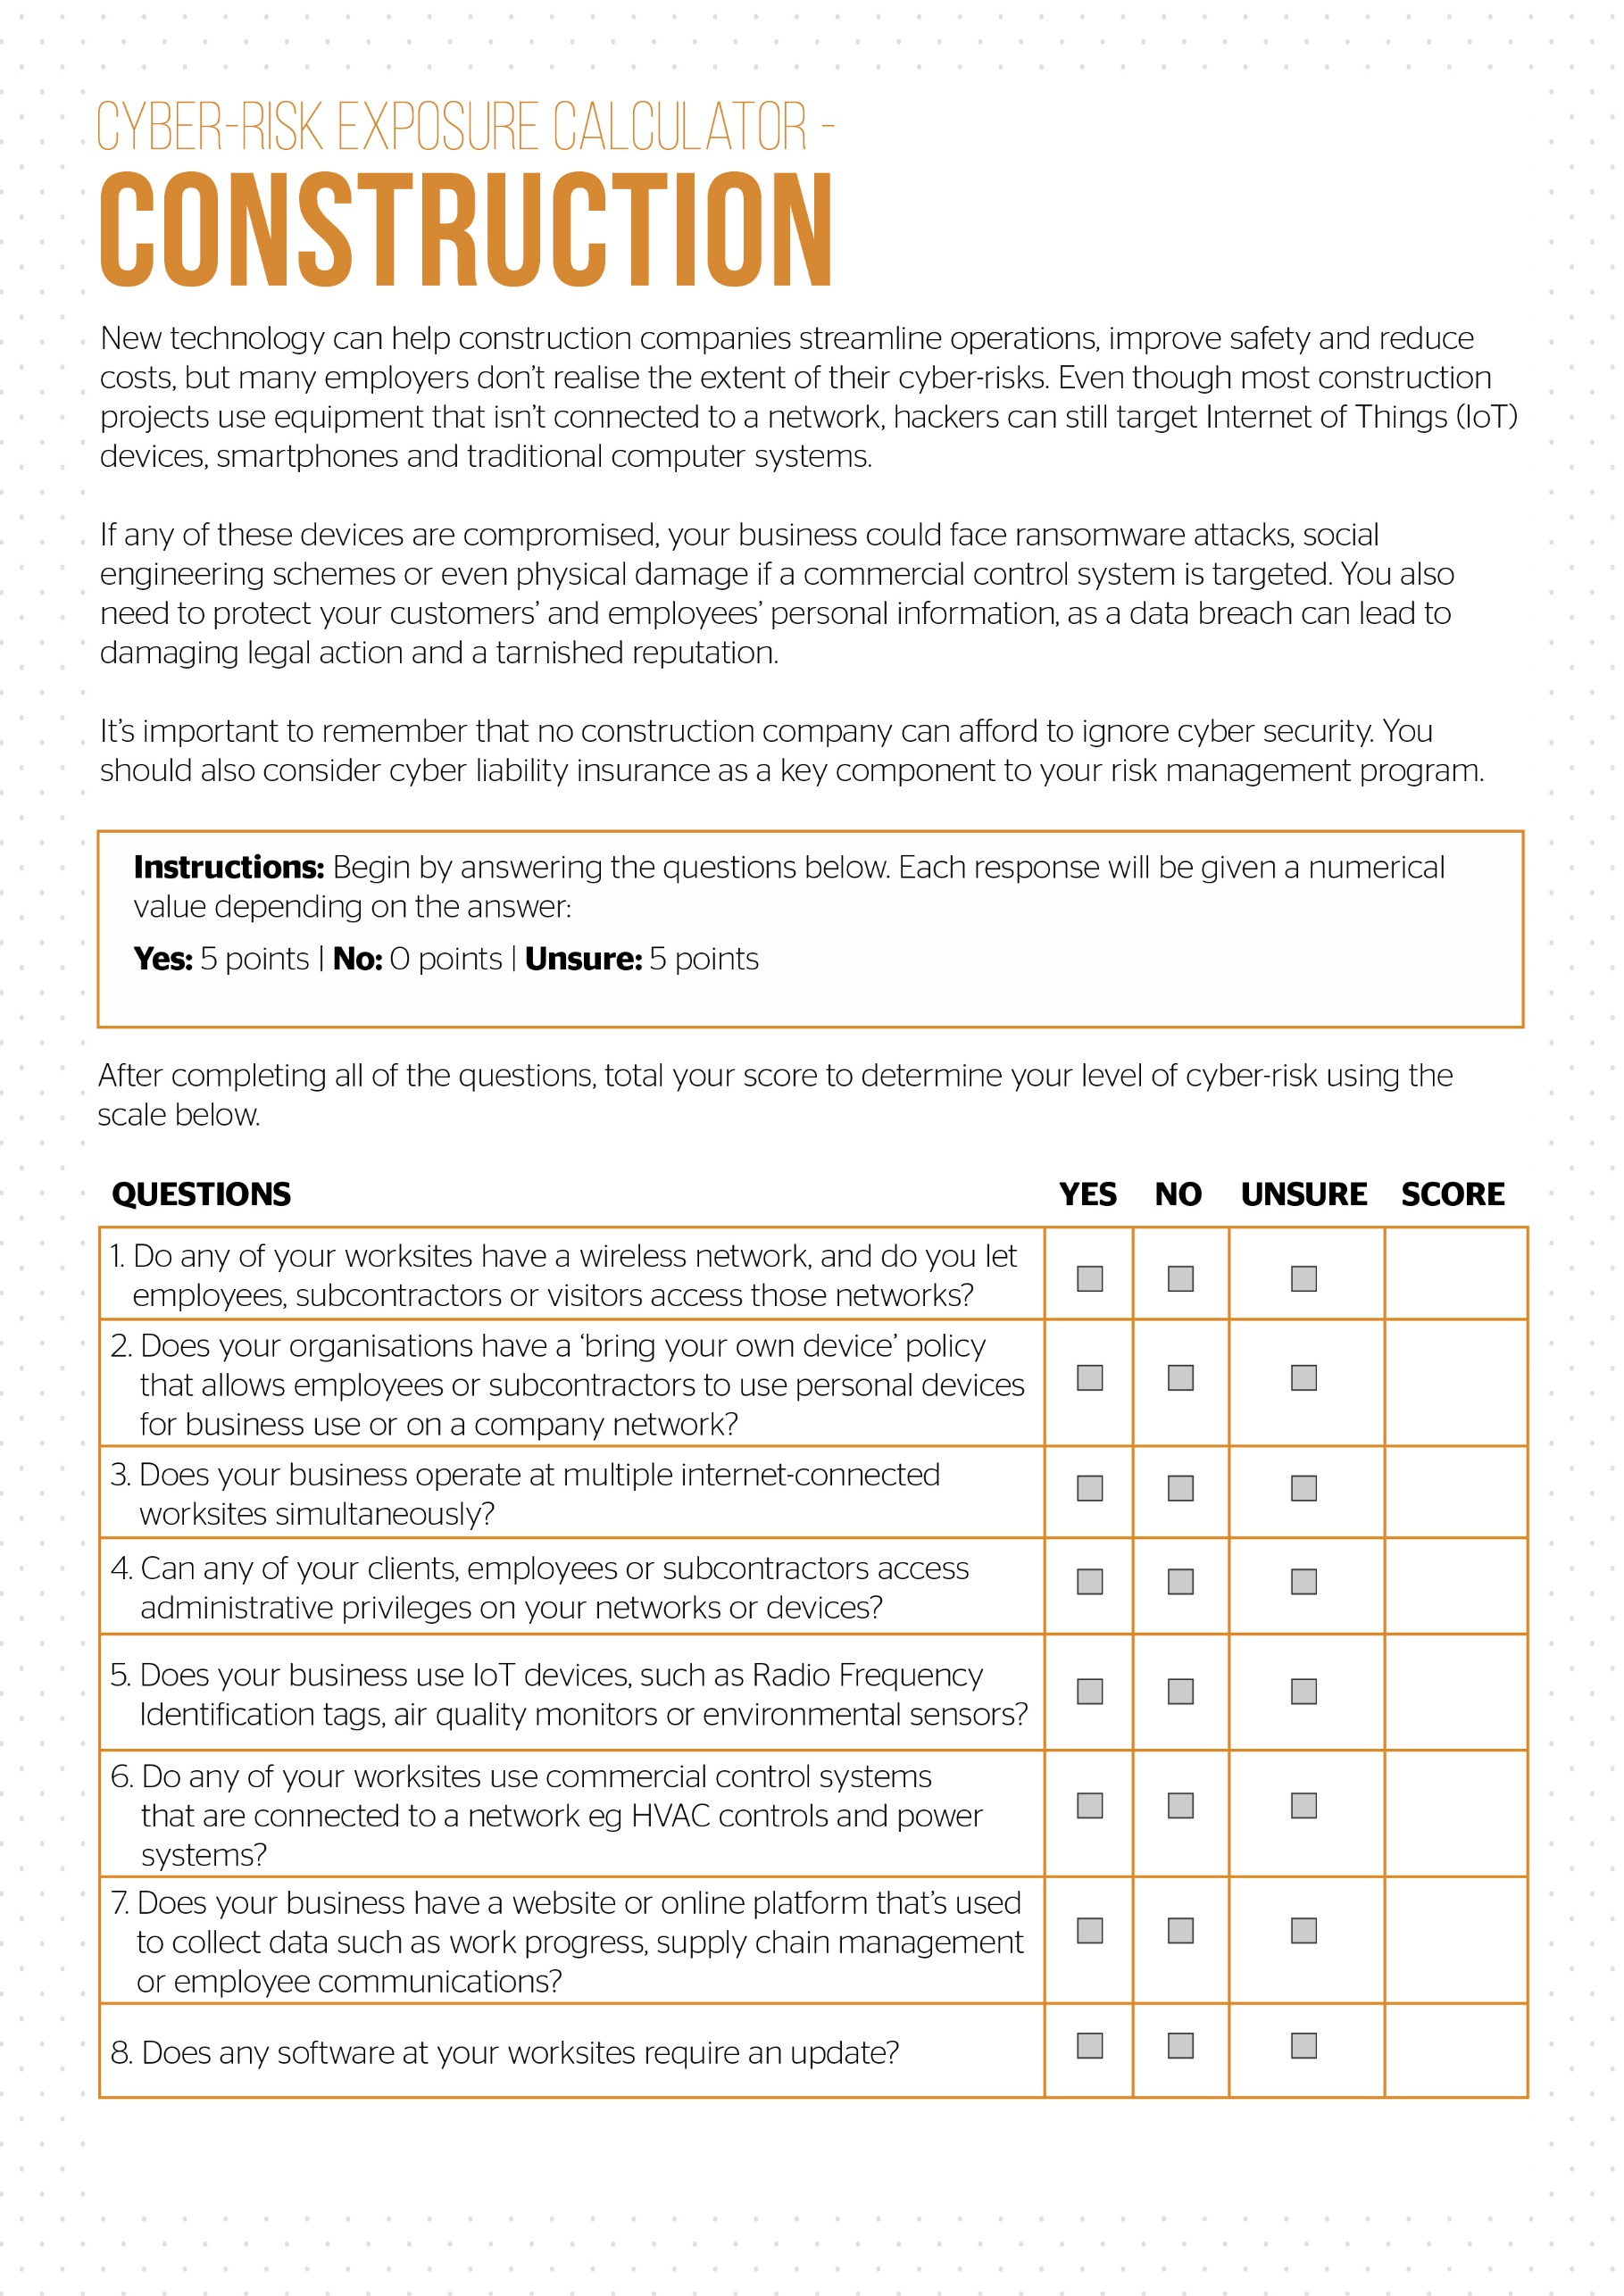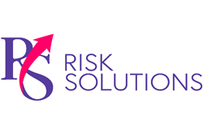

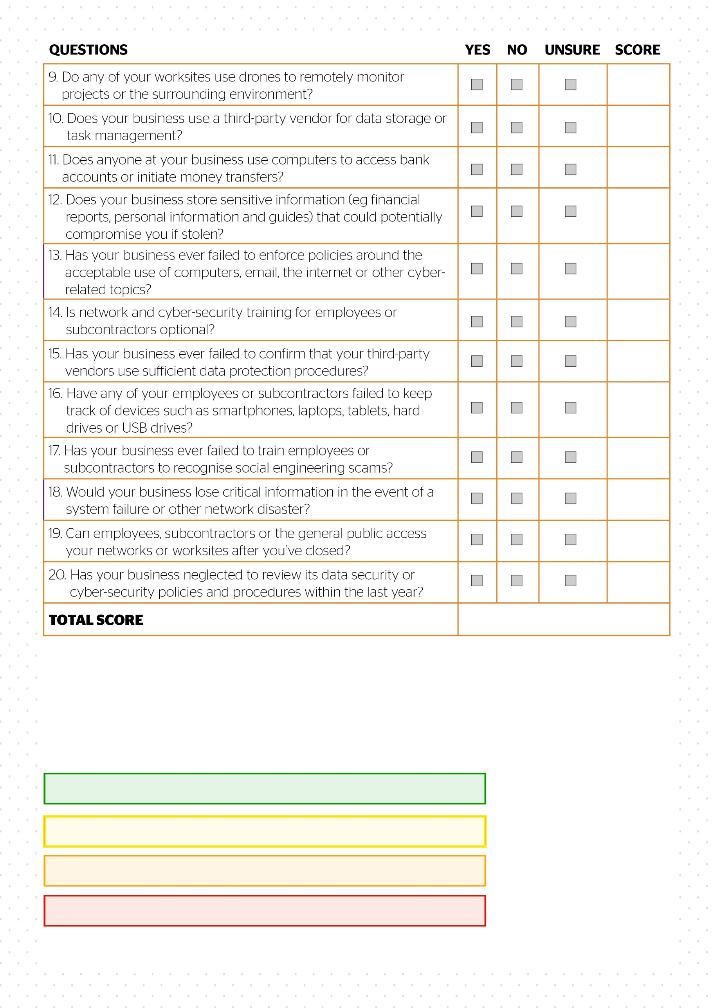

**Low risk.** Contact RS Risk Solutions Ltd to confirm: 0-10

**High risk.** Contact RS Risk Solutions Ltd to confirm: 30-50

**Moderate risk.** Contact RS Risk Solutions Ltd to confirm: 15-25

**Escalated risk.** Contact RS Risk Solutions Ltd to confirm: 55-100

© 2021 Zywave, Inc. All rights reserved.