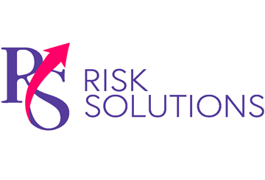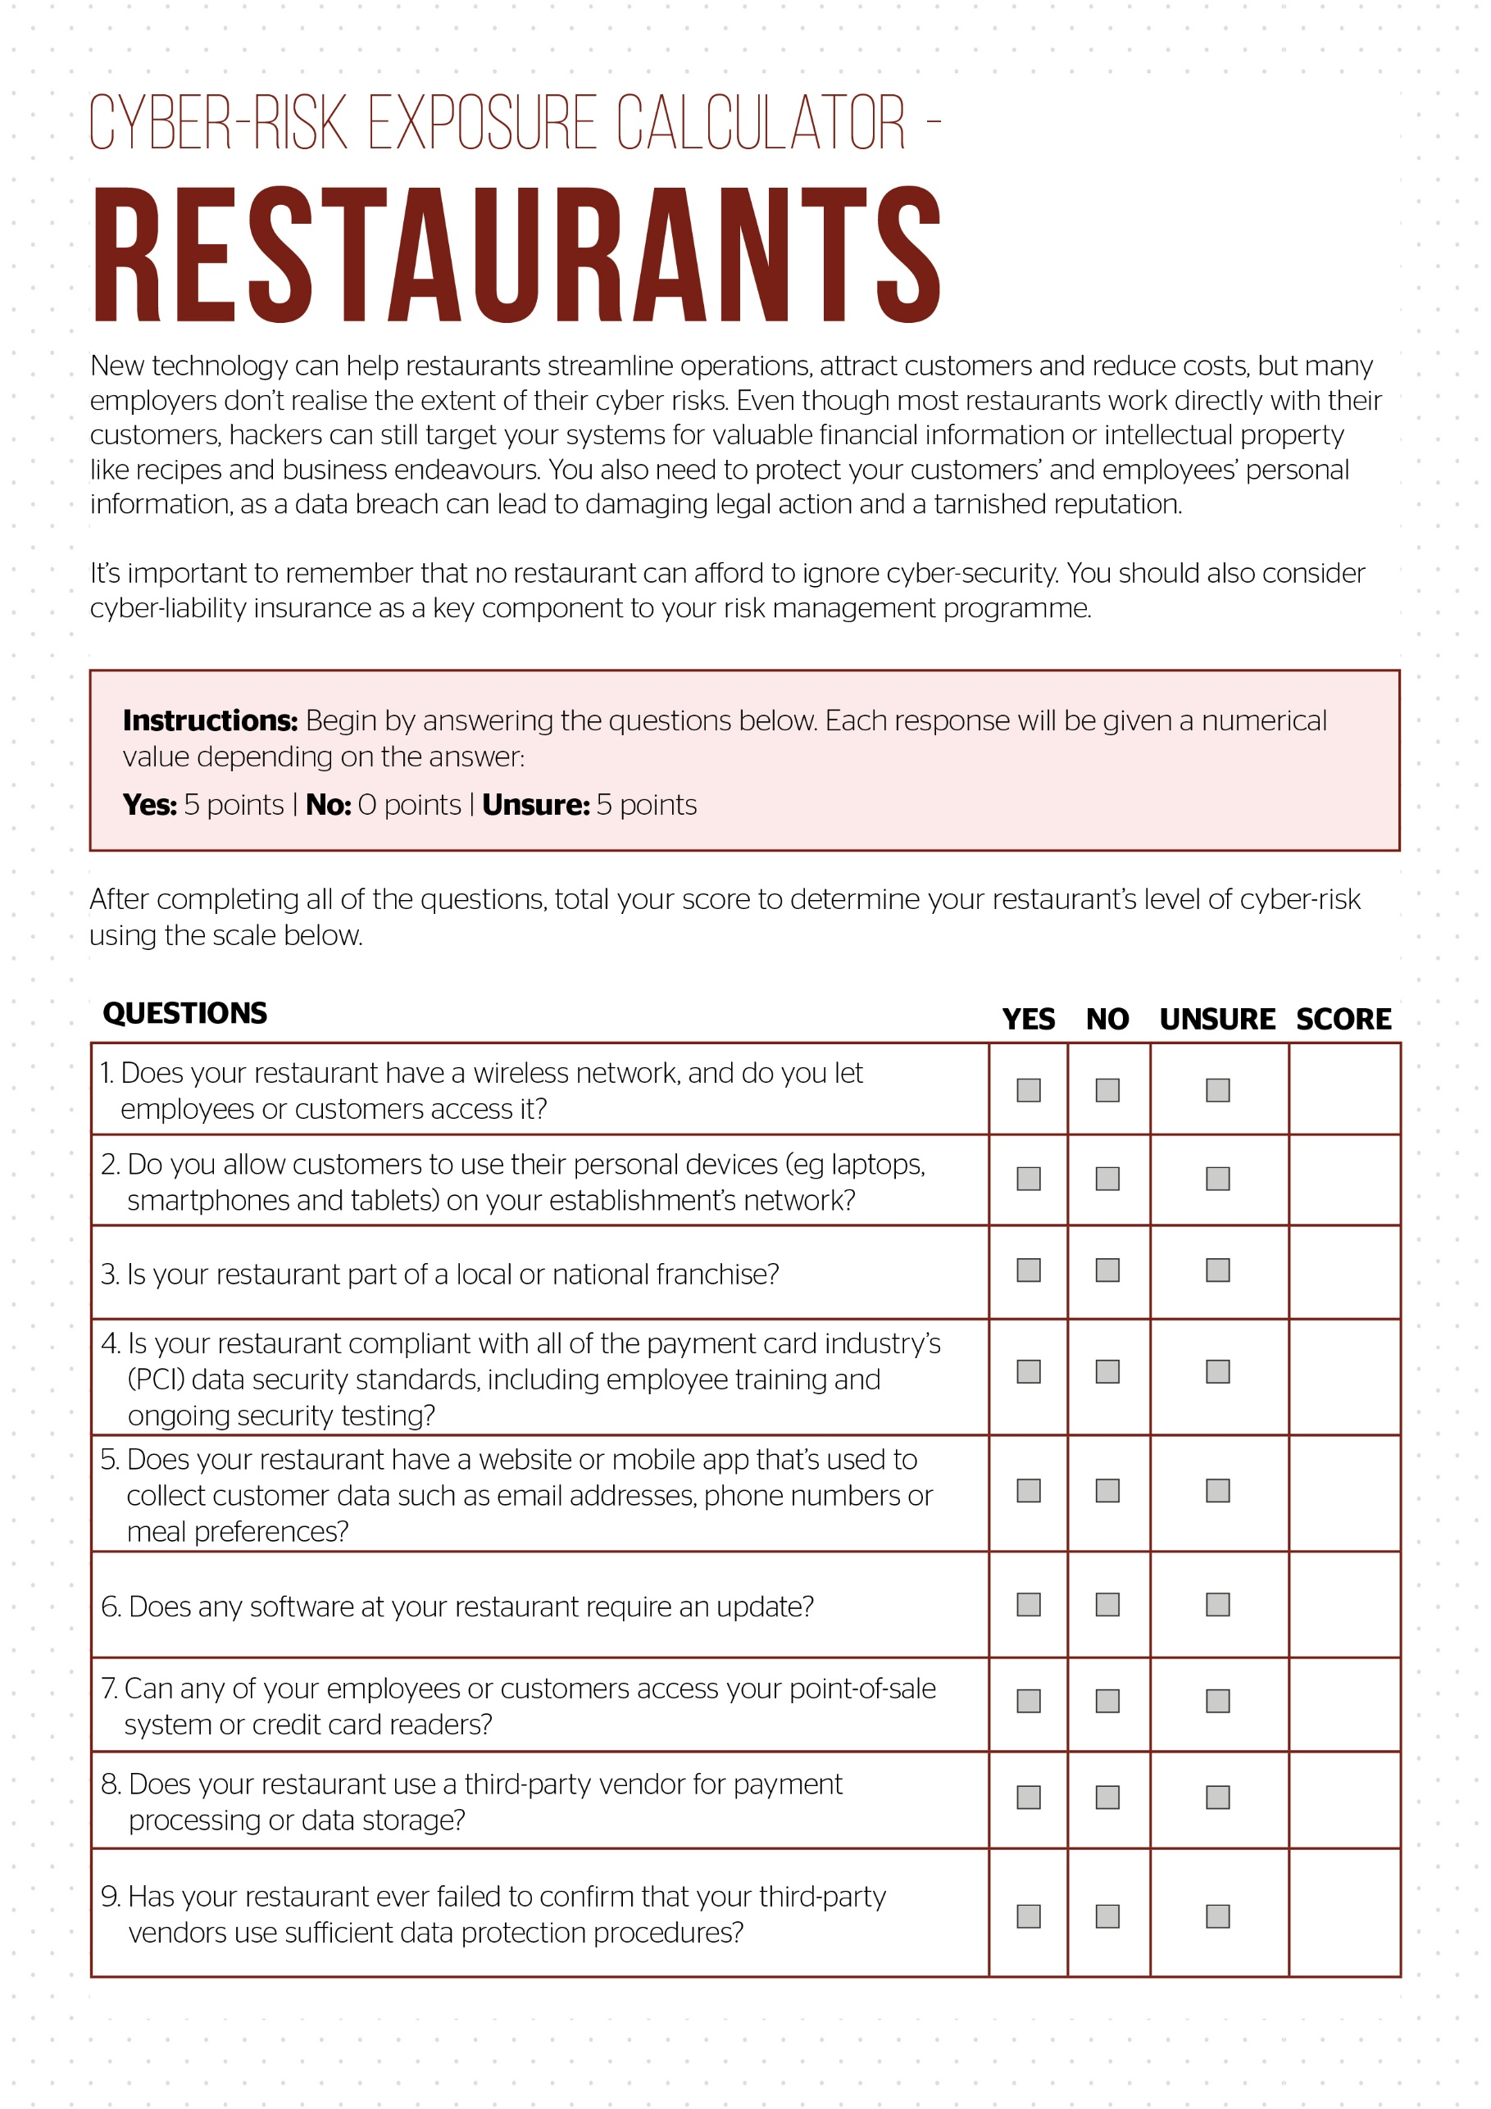

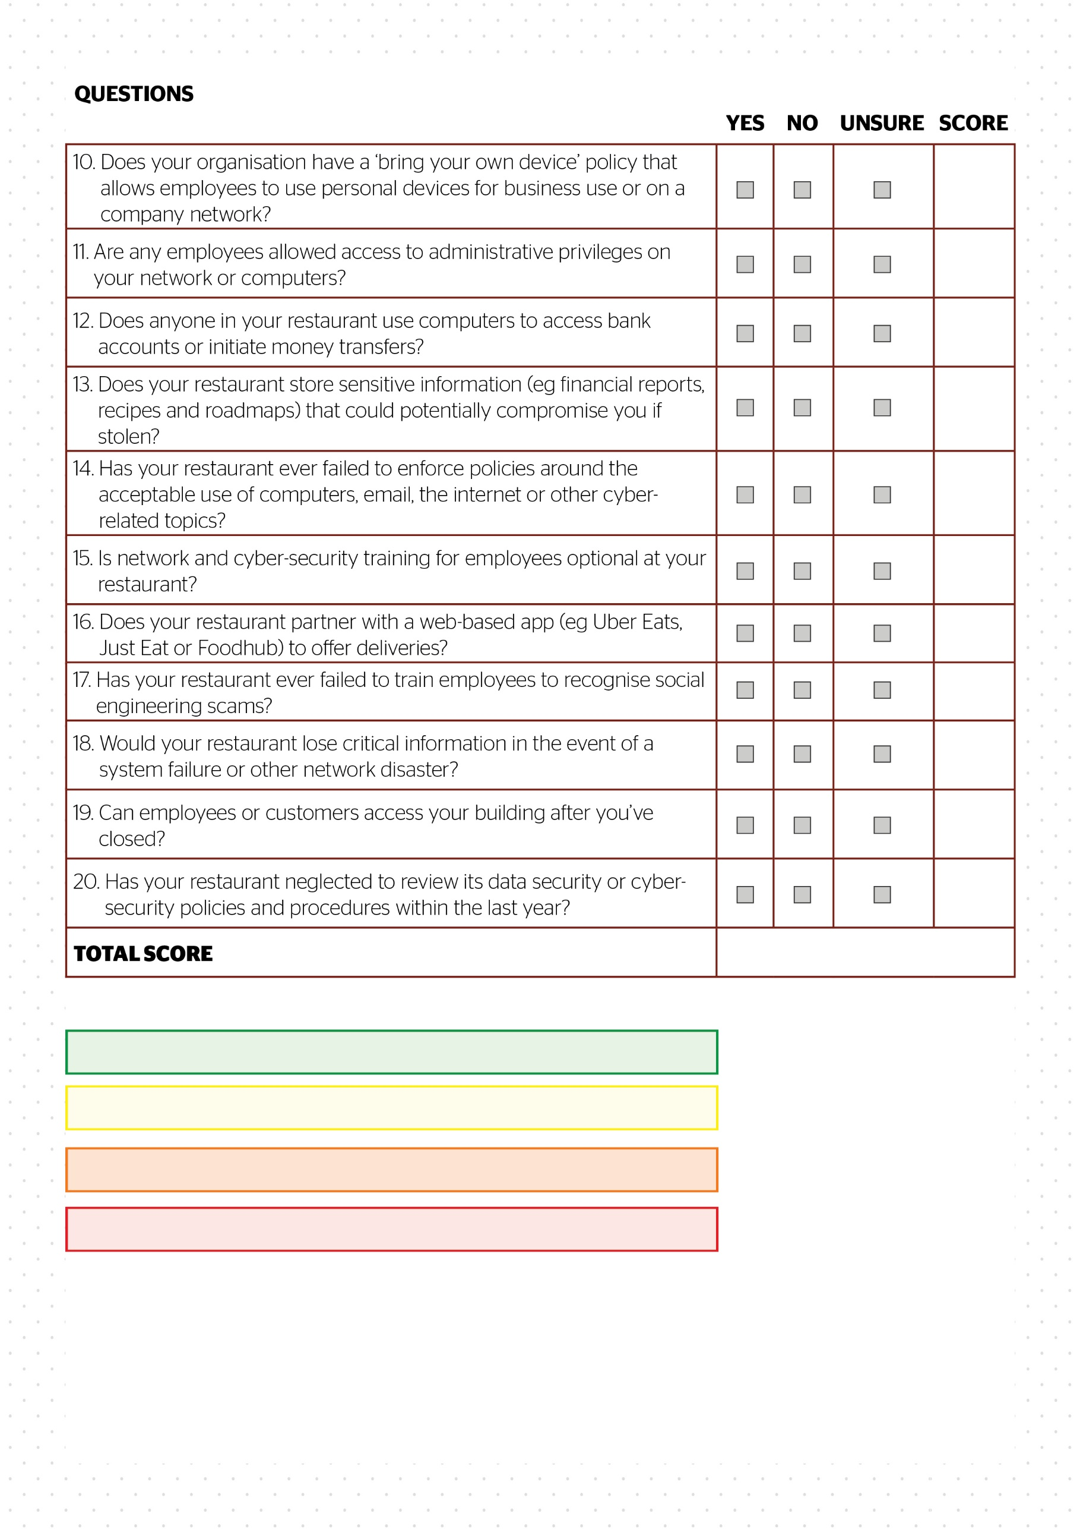

© 2021 Zywave, Inc. All rights reserved.

**Escalated risk.** Contact RS Risk Solutions Ltd today: 55-100

**High risk.** Contact RS Risk Solutions Ltd today: 30-50

**Medium risk.** Contact RS Risk Solutions Ltd today: 15-25

**Low risk.** Contact RS Risk Solutions Ltd to confirm: 0-10