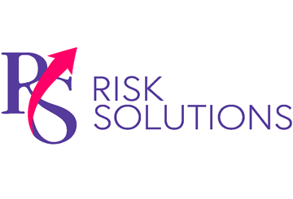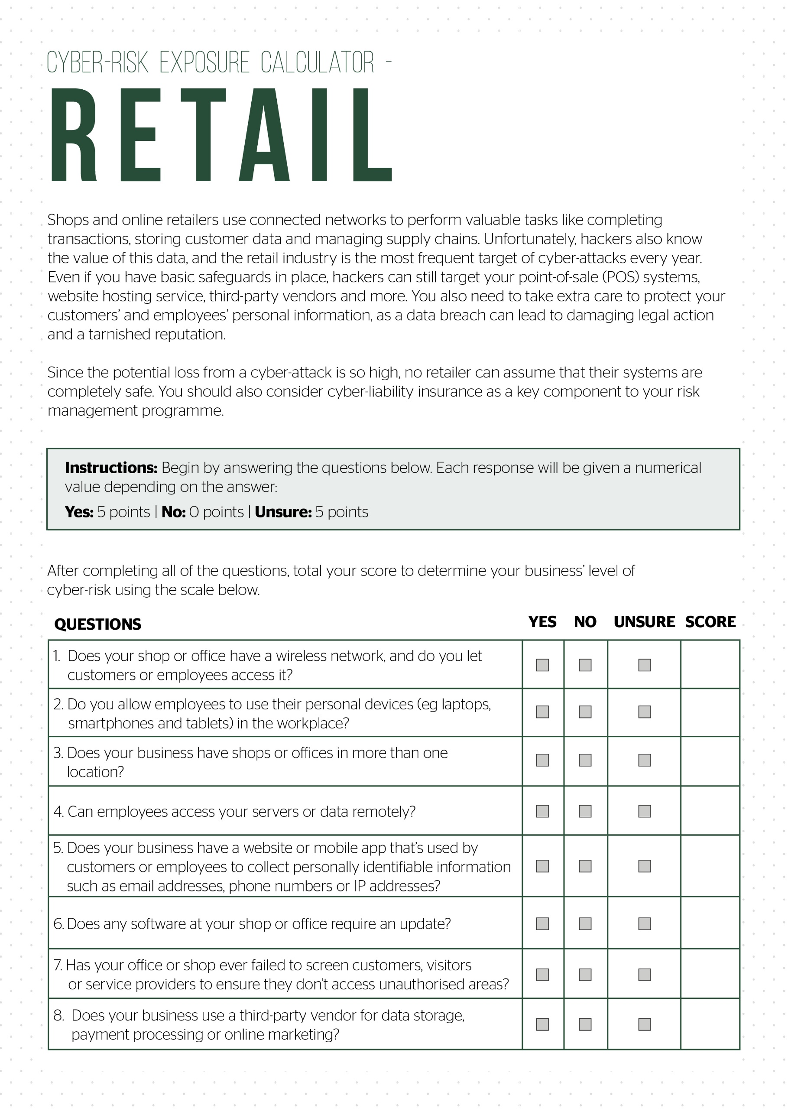

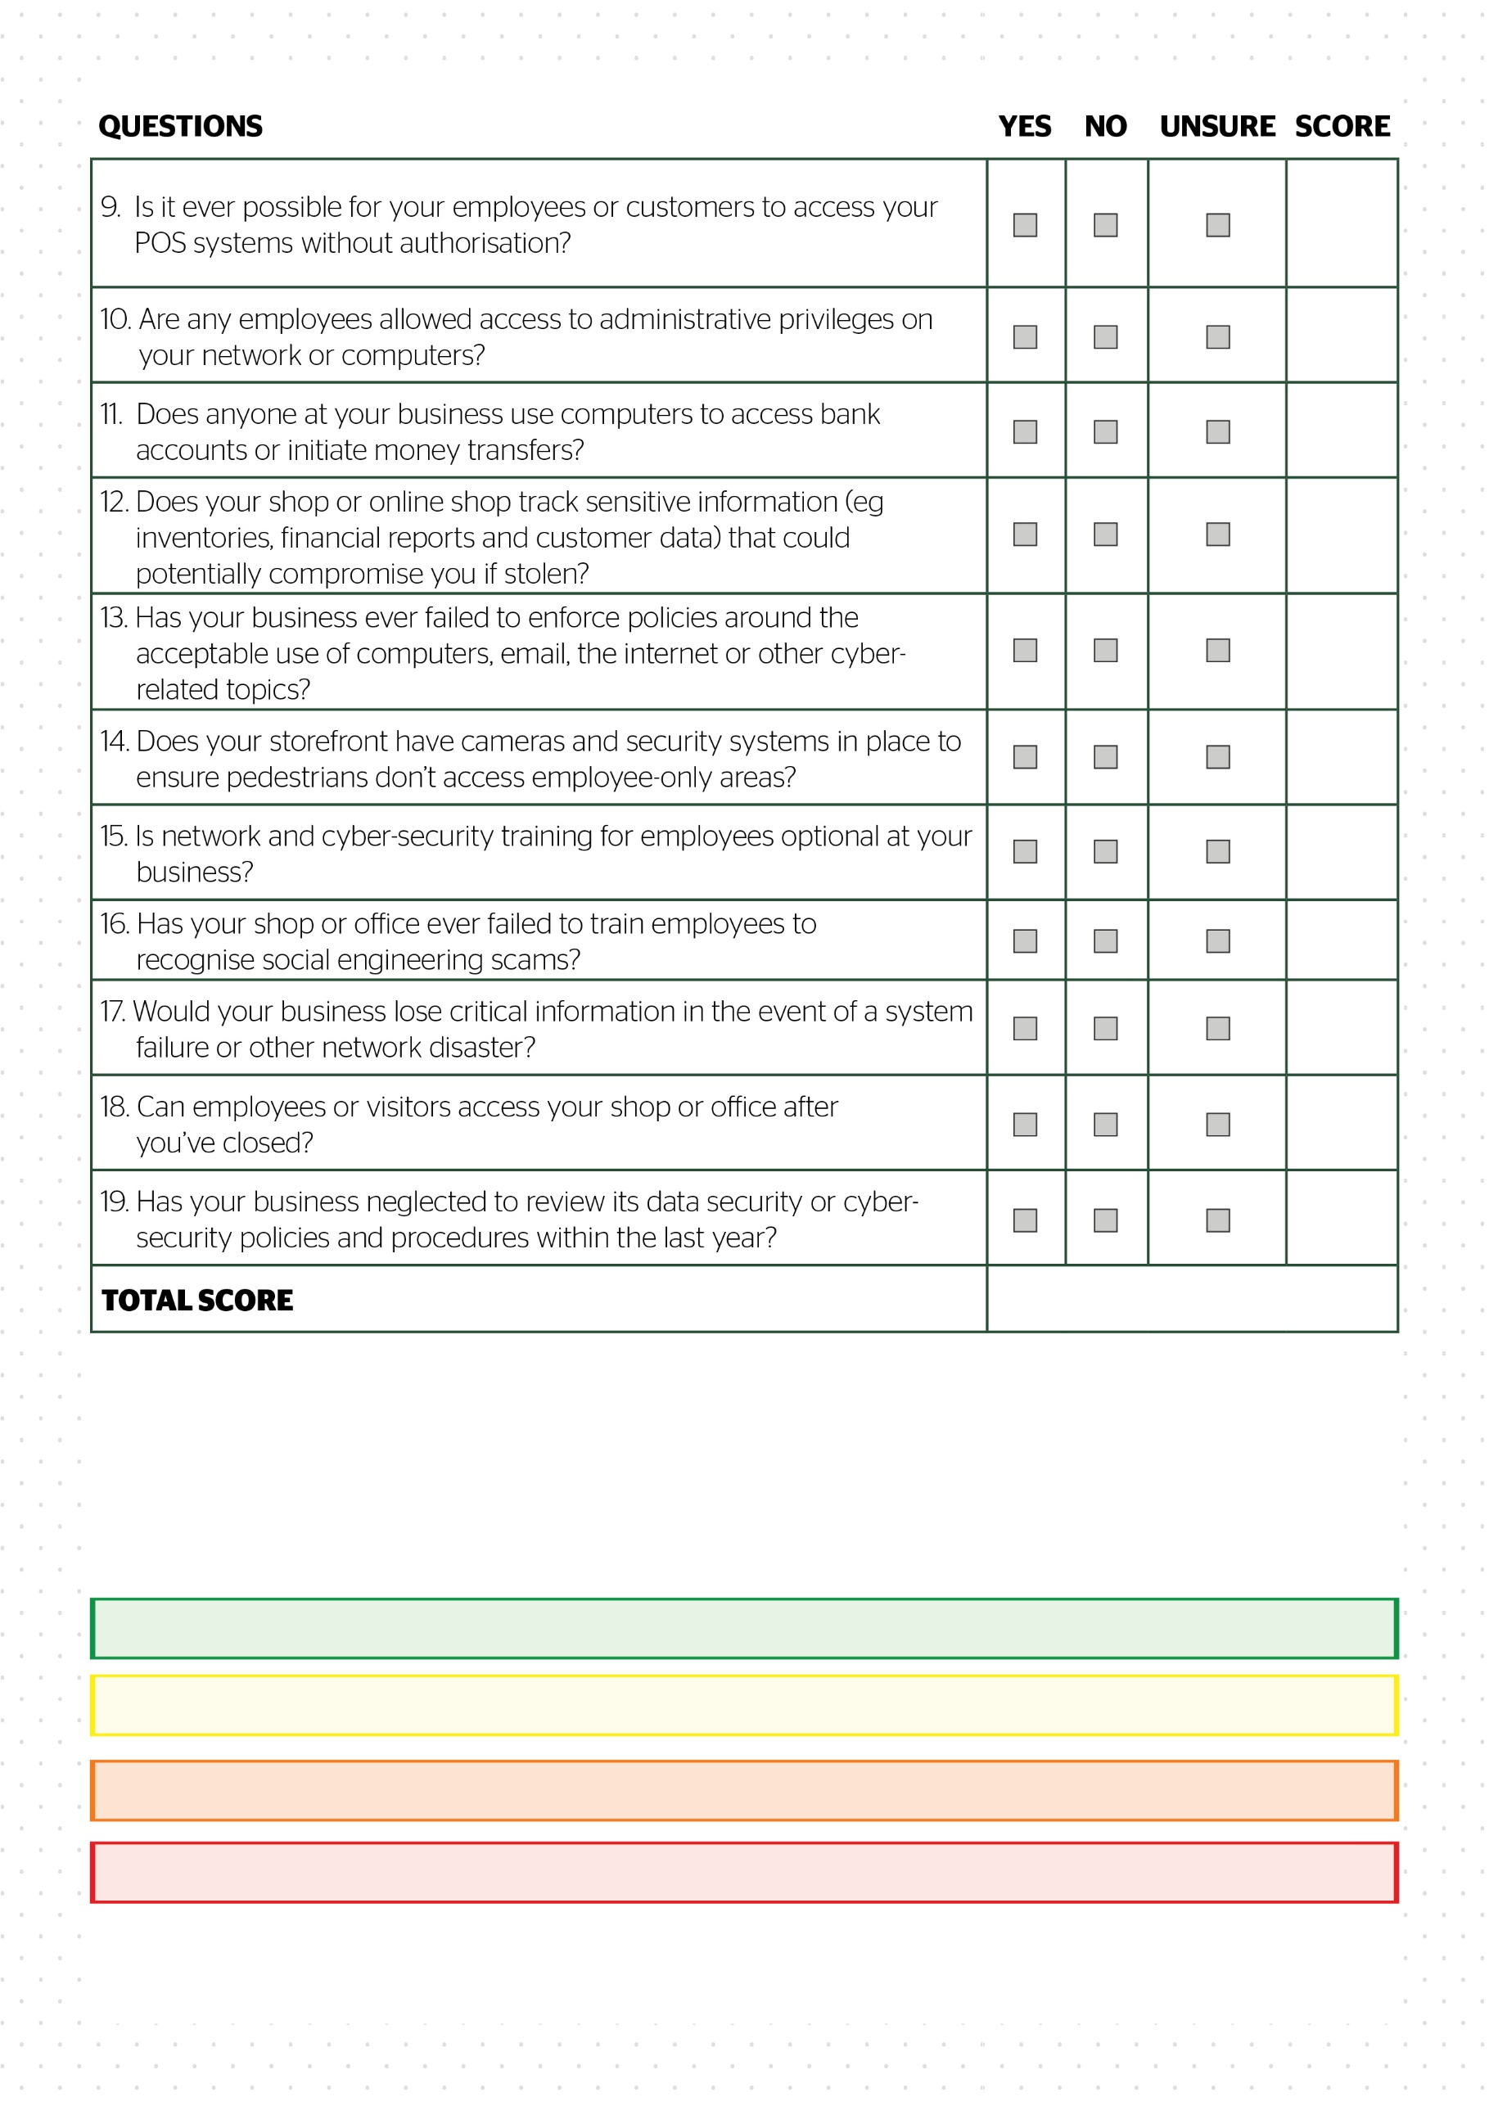

**Escalated risk.** Contact RS Risk Solutions Ltd to confirm: 55-95

**High risk.** Contact RS Risk Solutions Ltd to confirm: 30-50

**Moderate risk.** Contact RS Risk Solutions Ltd to confirm: 15-25

**Low risk.** Contact RS Risk Solutions Ltd to confirm: 0-10

© 2021 Zywave, Inc. All rights reserved.