DSE Assessment
WORKPLACE |  |  |  |  | DEPARTMENT
Workstation location/number (if applicable): |  | Users Name |  |  |  | Assessment Checklist reviewed by:
Date of Assessment: |  | Any further action needed? |  |  |  | Follow-up action completed on:
1. Display Screens
Problems to look for when making an assessment |  |  | Answer  YES or NO | Ways of reducing the risk |  |  | Action to take
Are the characters clear and readable?  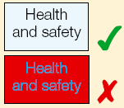 |  |  |  | Make sure the screen is clean and cleaning materials are made available.  Check that text and background colours work well together.
Is the text size comfortable to read?  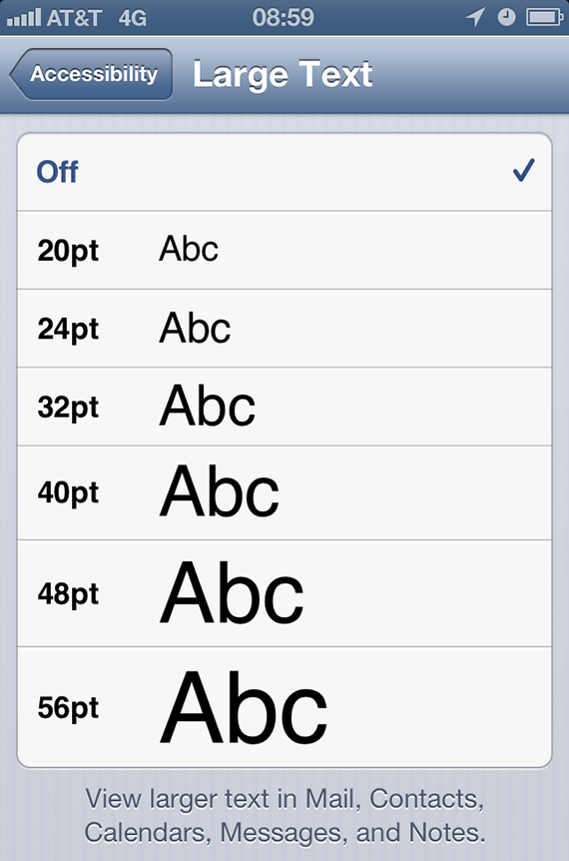 |  |  |  | Software settings may need adjusting to change text size.
Is the image stable, ie free of flicker and jitter?  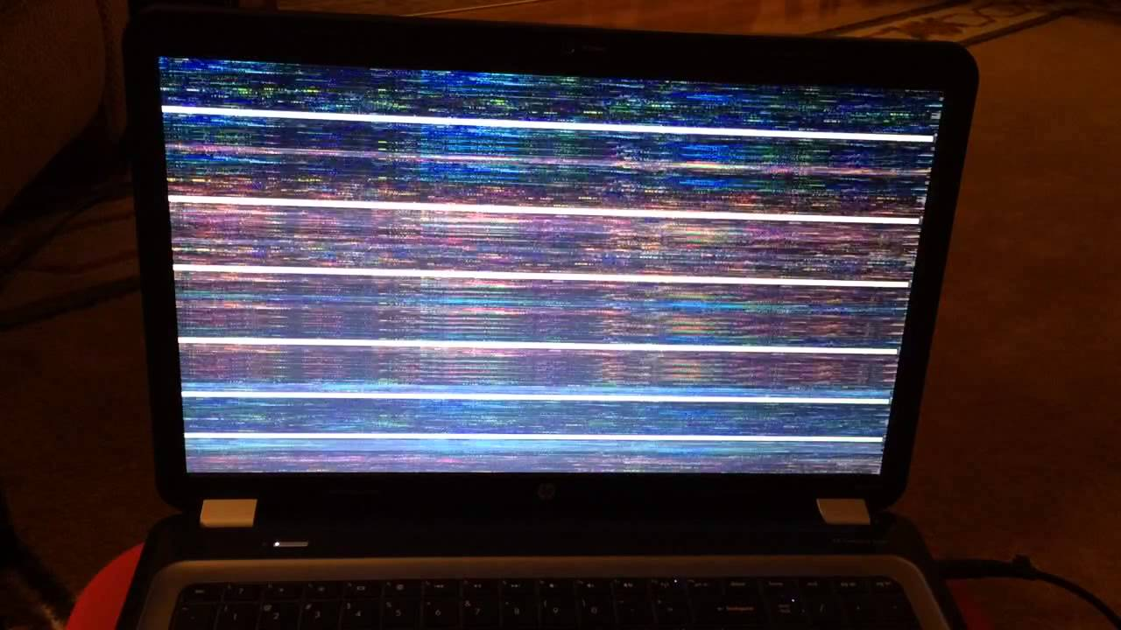 |  |  |  | Try using different screen colours to reduce flicker, eg darker background and lighter text.  If problems still exist, get the set-up checked, eg by the equipment supplier.

1. Display Screens
Problems to look for when making an assessment | Answer  YES or NO | Ways of reducing the risk | Action to take
Is the screen’s specification suitable for its intended use? |  | For example, intensive graphic work or work requiring fine attention to small details  may require large display screens.
Are the brightness and/ or contrast adjustable?  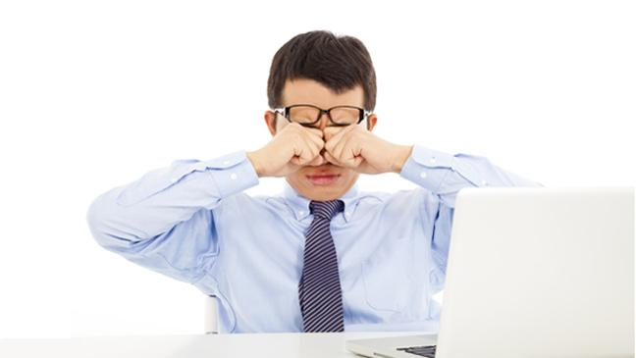 |  | Separate adjustment controls are not essential, provided the user can read the screen easily at all times.
Does the screen swivel and tilt?  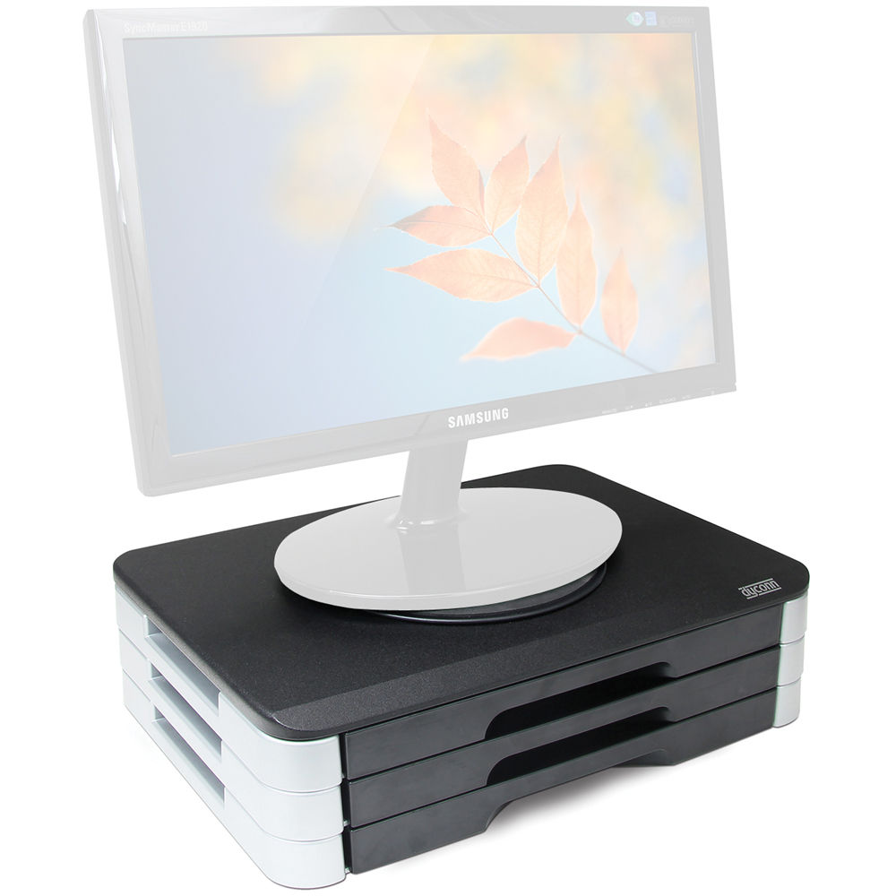 |  | Swivel and tilt need not be built in; you can add a swivel and tilt mechanism.  However, you may need to replace the  screen if:  - swivel/tilt is absent or unsatisfactory;  - work is intensive; and/or  - the user has problems getting the screen to a comfortable position.

1. Display Screens
Problems to look for when making an assessment | Answer  YES or NO | Ways of reducing the risk | Action to take
Is the screen free from glare and reflections?  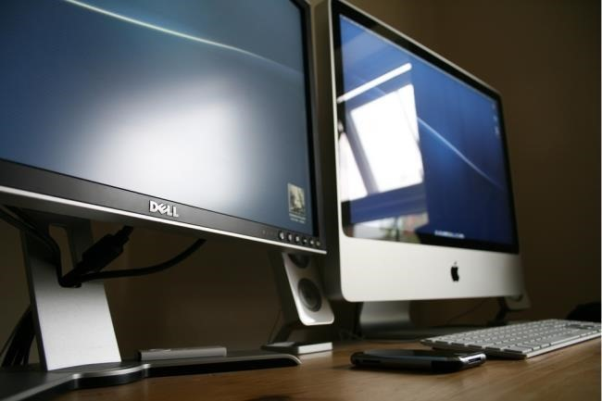 |  | Use a mirror placed in front of the screen to check where reflections are coming from.  You might need to move the screen or even the desk and/or shield the screen from the source of reflections.  Screens that use dark characters on a light background are less prone to glare and reflections.
Are adjustable window coverings provided and in adequate condition?  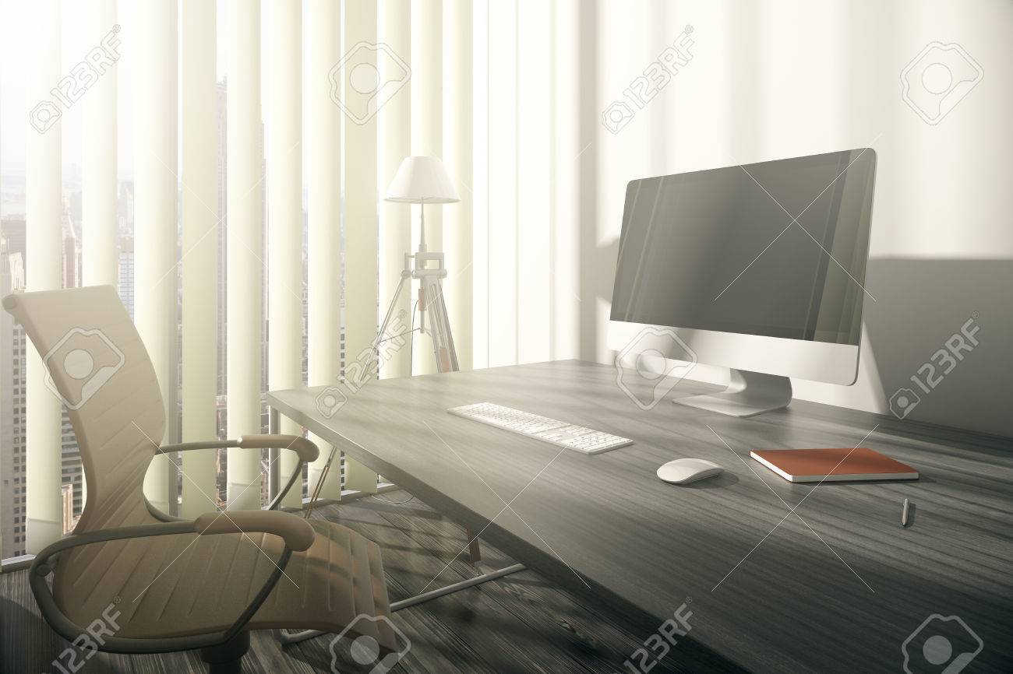 |  | Check that blinds work. Blinds with vertical slats can be more suitable than horizontal ones.  If these measures do not work, consider anti-glare screen filters as a last resort and seek specialist help.

2. Keyboards, mouse, trackball, etc.
Problems to look for when making an assessment | Answer  YES or NO | Ways of reducing the risk | Action to take
Is the keyboard separate from the screen?  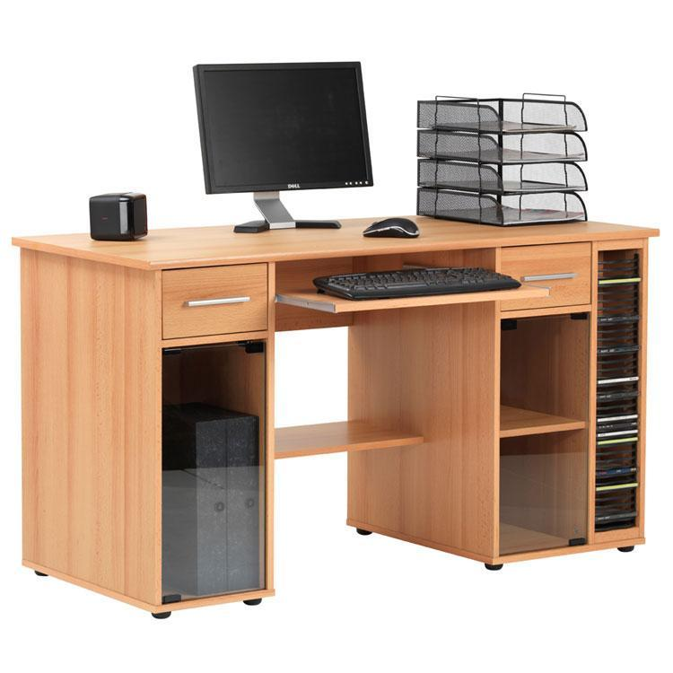 |  | This is a requirement, unless the task makes it impracticable (e.g. where there is a need to use a portable).
Does the keyboard tilt?  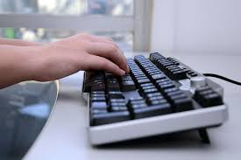 |  | Tilt need not be built in.
Is it possible to find a comfortable keying position?  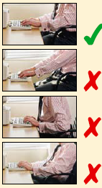 |  | Try pushing the display screen further back to create more room for the keyboard, hands and wrists.  Users of thick, raised keyboards may need a wrist rest.

2. Keyboards, mouse, trackball, etc.
Problems to look for when making an assessment | Answer  YES or NO | Ways of reducing the risk | Action to take
Does the user have good keyboard technique?  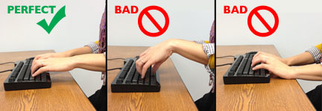 |  | Training can be used to prevent:  - hands bent up at wrist;  - hitting the keys too hard;  - overstretching the fingers.
Are the characters on the keys easily readable?  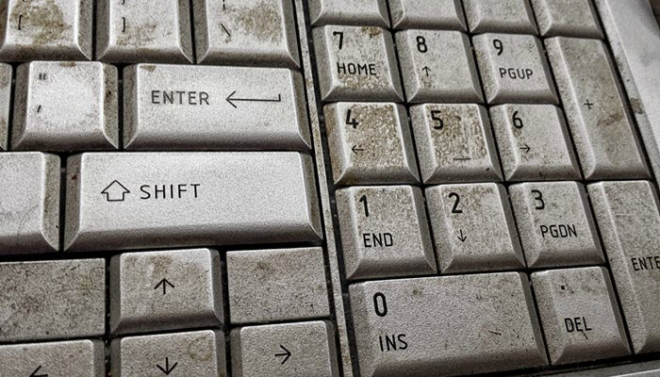 |  | Keyboards should be kept clean. If characters still can’t be read, the keyboard may need modifying or replacing.  Use a keyboard with a matt finish to reduce glare and/or reflection.
Is the mouse device suitable for the tasks it is used for? |  | If the user is having problems, try a different device. The mouse and trackball are general-purpose devices suitable for many tasks, and available in a variety of shapes and sizes. Alternative devices like touch screens may be better for some tasks (but can be worse for others).

2. Keyboards, mouse, trackball, etc.
Problems to look for when making an assessment | Answer  YES or NO | Ways of reducing the risk | Action to take
Is the device positioned close to the user?  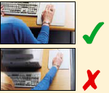 |  | Most devices are best placed as close as possible, eg right beside the keyboard.  Training may be needed to:  - prevent arm overreaching;  - tell users not to leave their hand on the device when it is not being used;  - encourage a relaxed arm and straight wrist.
Is there support for the device user’s wrist and forearm?  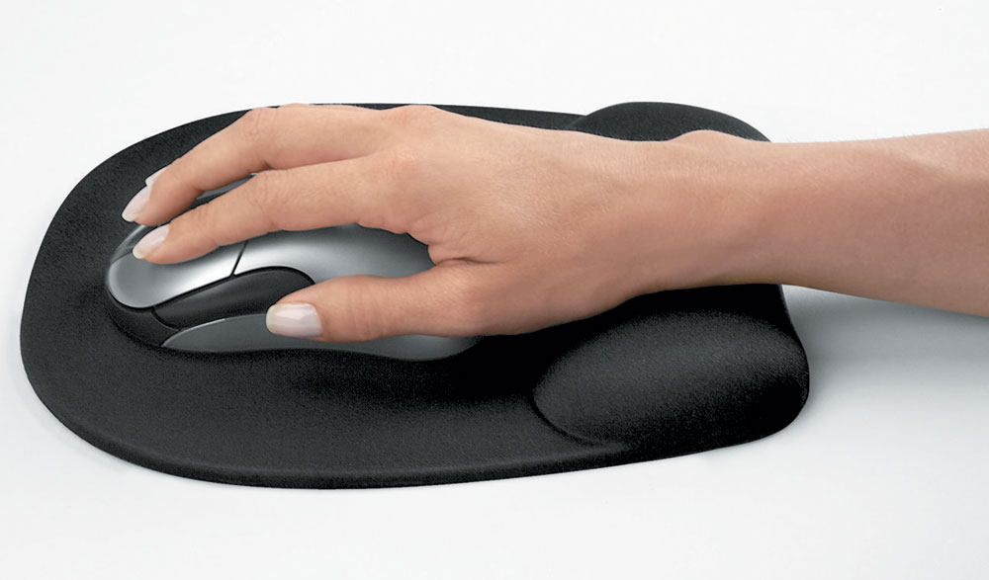  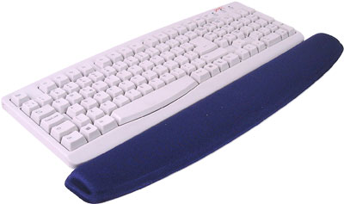 |  | Support can be gained from, for example, the desk surface or arm of a chair. If not, a separate supporting device may help.  The user should be able to find a comfortable working position with the device.
Does the mouse device work smoothly at a speed that suits the user?  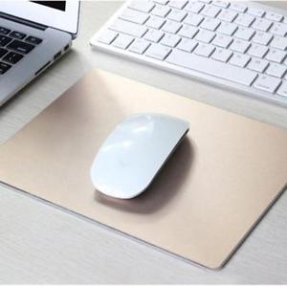 |  | See if cleaning is required (eg of mouse ball and rollers).  Check the work surface is suitable. A mouse mat may be needed.

2. Keyboards, mouse, trackball, etc.
Problems to look for when making an assessment | Answer  YES or NO | Ways of reducing the risk | Action to take
Can the user easily adjust software settings for speed and accuracy of pointer?  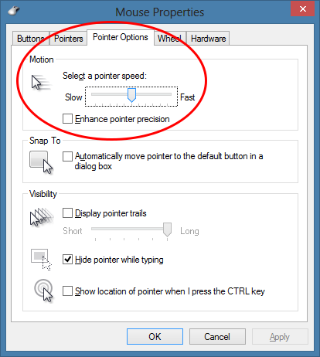 |  | Users may need training in how to adjust device settings.

3. Software
Problems to look for when making an assessment | Answer  YES or NO | Ways of reducing the risk | Action to take
Is the software suitable for the task?   |  | Software should help the user carry out the task, minimise stress and be user-friendly.  Check users have had appropriate training in using the software.  Software should respond quickly and clearly to user input, with adequate feedback, such as clear help messages.

4. Furniture
Problems to look for when making an assessment | Answer  YES or NO | Ways of reducing the risk | Action to take
Is the work surface large enough for all the necessary equipment, papers etc?  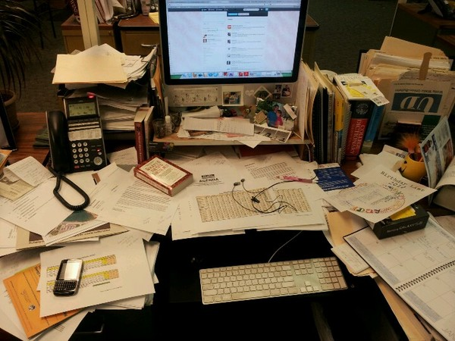✗  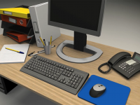 ✓ |  | Create more room by moving printers, reference materials etc elsewhere.  If necessary, consider providing new power and telecoms sockets, so equipment can be moved.  There should be some scope for flexible rearrangement.
Can the user comfortably reach all the equipment and papers they need to use?  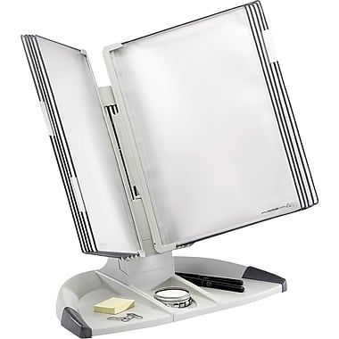 |  | Rearrange equipment, papers etc to bring frequently used things within easy reach.  A document holder may be needed, positioned to minimise uncomfortable head and eye movements.
Are surfaces free from glare and reflection?  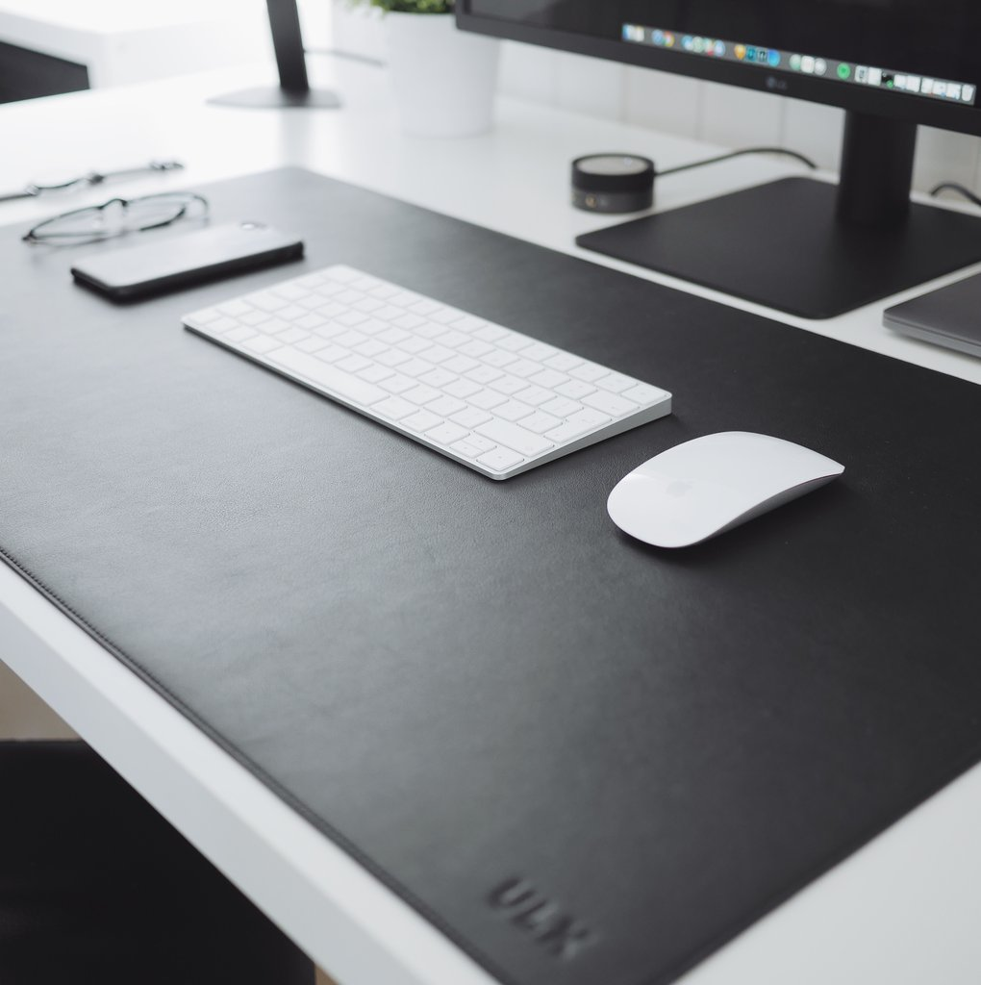 |  | Consider mats or blotters to reduce reflections and glare.

4. Furniture
Problems to look for when making an assessment | Answer  YES or NO | Ways of reducing the risk | Action to take
Is the chair suitable?  Is the chair stable?  Does the chair have a working:  - seat back height and tilt adjustment?  - seat height adjustment?  - swivel mechanism?  - castors or glides?  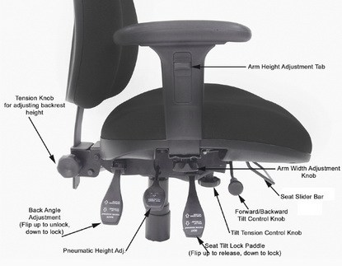 |  | The chair may need repairing or replacing if the user is uncomfortable, or cannot use the adjustment mechanisms.
Is the chair adjusted correctly?  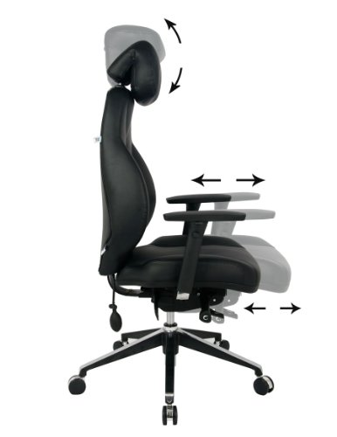 |  | The user should be able to carry out their work sitting comfortably.  Consider training the user in how to adopt suitable postures while working.  The arms of chairs can stop the user getting close enough to use the equipment comfortably.  Move any obstructions from under the desk.

4. Furniture
Problems to look for when making an assessment | Answer  YES or NO | Ways of reducing the risk | Action to take
Is the small of the back supported by the chair’s backrest?  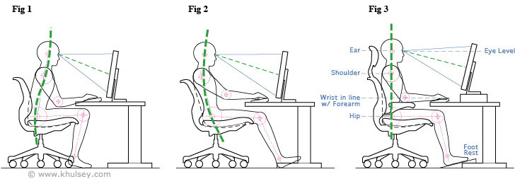  ✗ ✗ ✓ |  | The user should have a straight back, supported by the chair, with relaxed shoulders.
Are forearms horizontal and eyes  at roughly the same height as the top of the VDU?  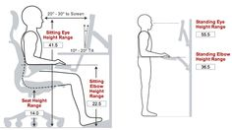 |  | Adjust the chair height to get the user’s arms in the right position, then adjust the VDU height, if necessary.
Are feet flat on the floor, without too much pressure from the seat on the backs of the legs? |  | If not, a foot rest may be needed.
Is there enough room to change position and vary movement? |  | Space is needed to move, stretch and fidget.  Consider reorganising the office layout and check for obstructions.  Cables should be tidy and not a trip or snag hazard.

5. Environment
Problems to look for when making an assessment | Answer  YES or NO | Ways of reducing the risk | Action to take
Is the lighting suitable, eg, not too bright or too dim to work comfortably?  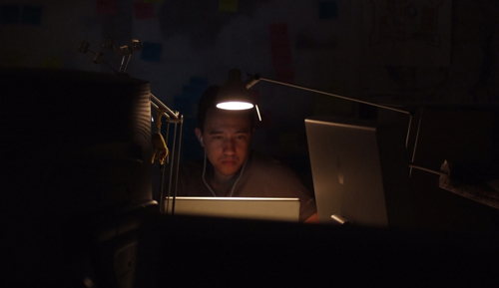 ✗  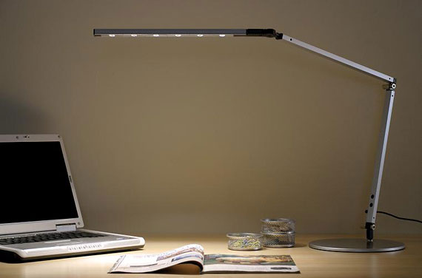 ✓ |  | Users should be able to control light levels, eg by adjusting window blinds or light switches.  Consider shading or repositioning light sources or providing local lighting, eg desk lamps (but make sure lights don’t cause glare by reflecting off walls or other surfaces).
Does the air feel comfortable? |  | VDUs and other equipment may dry the air. Circulate fresh air if possible. Plants may help.  Consider a humidifier if discomfort is severe.
Are levels of heat comfortable?  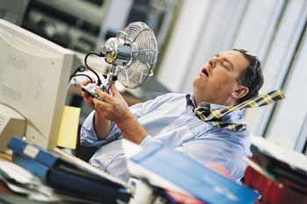 |  | Can heating be better controlled? More ventilation or air-conditioning may be required if there is a lot of electronic equipment in the room. Or, can users be moved away from the heat source?
Are levels of noise comfortable?  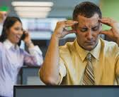 |  | Consider moving sources of noise, eg printers, away from the user. If not, consider soundproofing.

6. Questions for users... | Answer  YES or NO
- Has the checklist covered all the problems that you have working with your display screen equipment?
- Have you experienced any discomfort or other symptoms which you can attribute to working with your Display Screen Equipment?
- Are you aware of your entitlement to eye and eyesight testing?
- Do you take regular breaks working away from Display Screen Equipment?
Further Comments

Risk Assessment: Display Screen Equipment
Control Measure: |  |  | Priority Rating
Person Responsible for Action(s):
P1= Priority 1 Action Now | P2 = Priority 2 Action 2-3 Months | P3 = Priority 3 Action 3-6 Months
DISPLAY SCREEN EQUIPMENT ASSESSMENT APPENDIX
Guidance to Help Assessor

 | RECOMMENDED  RANGE | COMMENTS
S-1 DESK
height
Width | 600mm min / 800mm pref
Length | 1200mm min / 1600mm pref
Height | 660-730mm / 720mm pref
Thickness | Thin as possible <40mm
S-2 LEGROOM
Width (across Knees) | 580mm min / 610mm pref
Depth | 450mm min
Height | 620mm min
Footroom Depth | 600mm min

S-3 CHAIR
Seat Height (a) | 420 – 500mm
Backrest Height (b) | 170 - 230mm
Backrest Width (e) | 360 - 400mm
Seat Depth c) | 380mm min
 | 430mm max fixed backrest
 | 470mm max adj backrest
Seat Width (d) | 360 - 400mm

S-4 ARMRESTS
Height (f) | 200mm min / 250mm max
Width between armrests (g) | 460mm min / 525mm max
Length (h) | 200mm min
Width (I) | 40mm min
Distance from front (j) | 100mm min

S-5 ENVIRONMENT
Lighting Range | 300 - 500 lux
Humidity | 40% - 60%
Temperature | 19ºC – 23ºC

Display Screen Equipment

Best Practice Guidelines and Risk Assessment

Employees who continuously use computers (desktop and laptop) and other equipment that incorporates visual display screens as part of their working activities are subject to potential work related injuries such as:

- Musculoskeletal disorders e.g. back pain, upper limb disorders and repetitive strain injuries
- Visual fatigue
- Mental stress

Consequently, display screen workstations should be assessed to ensure the health and safety of those who use them. The following requirements should be met to provide a safe workstation:

1. The Environment:

- Adequate illumination with no reflection or glare on screen.
- No bright distracting lights in the users’ field of vision.
- Temperature and humidity to be comfortable.

2. The Screen:

- Should be adjustable in tilt, swivel and preferably height.
- Should have brightness and contrast adjustment.
- Characters should be stable (no flicker) and sharp.

3. Desk:

- Must be adequate in size to accommodate components of the workstation without clutter.
- Should have sufficient height to allow for unhindered knee space.
- Should have sufficient free under desk floor space for feet, legs and knees
- Should have matt (non-reflective) surface.

4. Copy stand (if needed):

- Should be provided and positioned at the same height and distance as screen.

5. Keyboard /Mouse:

- The Keyboard should have a flat profile.
- The Keyboard should be adjustable, tilt and should have a non-reflective surface.
- The Mouse – when using the mouse it should be kept close to the body and within easy reach so that it can be used with the wrist straight.
- Try and maintain an angle of ninety degrees between shoulder/forearm/wrist/hand and the mouse.
- Sit upright and close to the desk so that the arm used to operate the mouse is not stretched and is not kept in a locked position.
- Support the forearm on the desk with the elbow bent and do not grip the mouse too tightly.
- Rest your fingers lightly on the buttons and do not press them hard.
- People who are left-handed should consider using the appropriate software to convert the mouse for left hand use.

6. Feet:

- Should be flat on the ground or on a foot-rest where feet cannot reach the ground.

7. Head:

- Should be balanced, with chin up and no strain on the neck muscles.

8. Eyes:

- Should look down at the screen with an angle of about 15 degrees from the horizontal.
- Eyesight should be tested and corrected if necessary for the viewing distance of the screen and copy.

9. Shoulders:

- Should be in a comfortable position – relaxed and not hunched.

10. The Upper Arm:

- Should be positioned vertically with the elbow at right angles.

11. The Wrist:

- Should be straight when typing and supported during breaks.

12. Chair Back:

- Should be adjustable in height and tilt so that the curvature of the lower back is supported.
- Full-length backrests can also provide support to the upper back and head.

13. Sitting:

- Sit well back in the chair so that the backrest supports the lower back.
- Pull the chair forward to find the right keyboard position – do not sit on the edge of the chair.
- The hip should be at right angles.

14. The Chair Seat:

- Should be adjustable in height to find the correct position for the forearms.
- If this causes the feet to be off the floor - use a footrest.

15. The Chair Base:

- Should be stable – ideally with castors.

Risk Assessment

A risk assessment should help to identify that the above criteria are being met along with any unseen problems such as any upper limb pain, address any problems identify in your risk assessments and review these on a regular basis e.g. when purchasing new equipment, change of process, change of equipment, every 12-18 months.

Those who use the equipment continuously for more than one hour at a time are classified as Users. Users are entitled to free eye checks and where required, glasses for VDU use. The costs associated with both of these entitlements are borne by their employer.

Laptop users should where possible use a docking station and a full sized keyboard.

Regular short breaks away from the equipment or change of tasks will do much to reduce the chance of injury as they prevent overusing the same set of muscles for a prolonged time.

