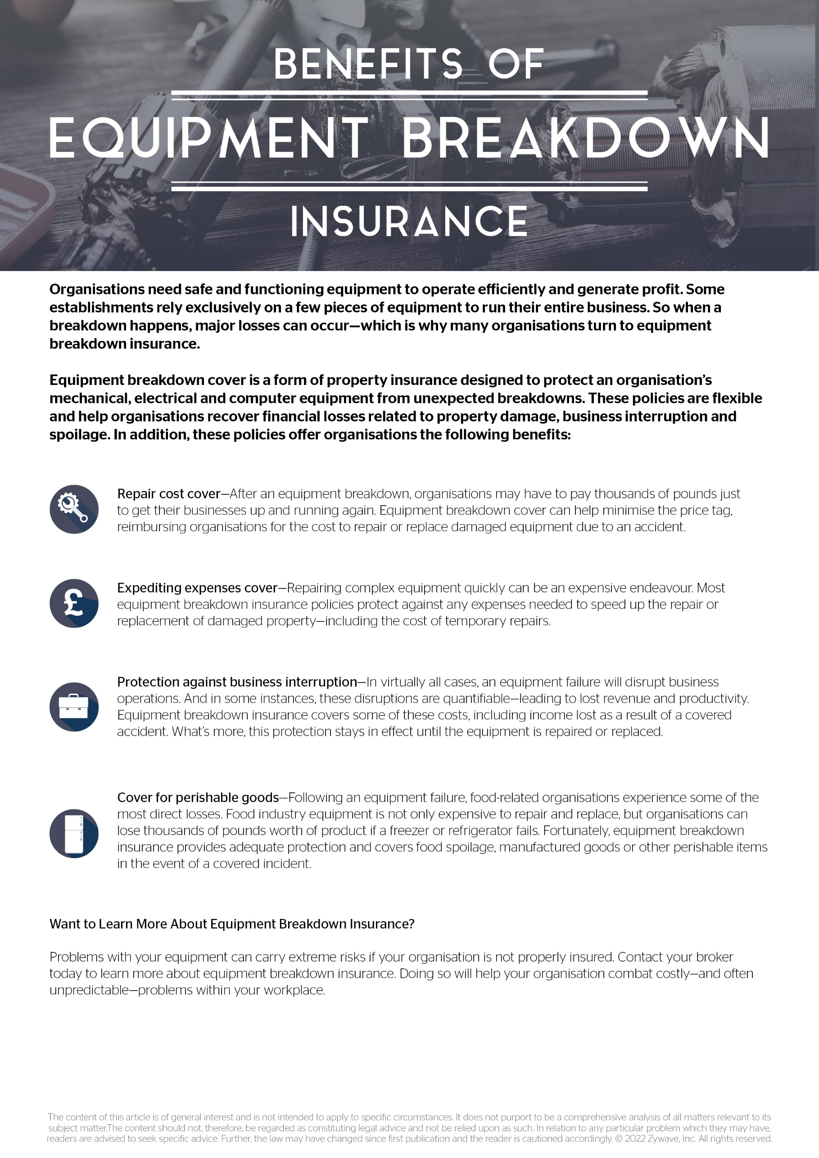

Presented by: RS Risk Solutions Ltd