Get Walking to Get Healthy

May is National Walking Month in the UK. While often seen as a leisure pursuit, walking is one of the easiest ways to get active, and you don’t have to walk for hours to see significant health benefits. In fact, just 10 minutes of brisk walking daily can reduce your risk of early death by 15%, according to Public Health England.

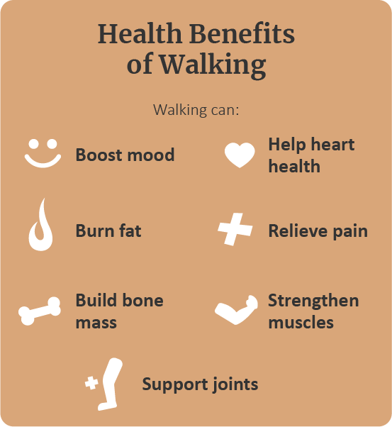Further validating this research, recent analysis in the British Journal of Sports Medicine found that 1 in 10 premature deaths could be prevented if everyone did as little as 11 minutes of daily activity. While the [NHS physical activity guidelines](https://www.nhs.uk/live-well/exercise/exercise-guidelines/) are still best for optimal health, smaller amounts of activity—including walking—are beneficial. With this in mind, bolster your well-being in May by celebrating National Walking Month.

As you incorporate walking into your daily routine, consider the following guidance:

* **Wear the correct shoes**. Whether you walk outdoors, on a treadmill or at the local shopping centre, a good pair of shoes is essential. While fit-for-purpose walking shoes are ideal, any shoes or trainers that are comfortable, give you adequate support and don't cause blisters will suffice.
* **Consider your safety**. The appropriate safety precautions should be taken when walking outside. Specifically, always walk on pavements, be aware of traffic and wear reflective clothing when walking in darkness. Additionally, gradually increase your walking distance to avoid injuries.
* **Set a good pace.** To start, you should walk for 30 minutes daily at a “talking” pace—where you’re able to comfortably carry on a conversation. As you improve, try to incorporate brisk walking. You can tell you’re walking briskly if you can still talk but can’t sing the words to a song. Consider leveraging smartphone apps to track your walking pace and distance.
* **Walk with others**. To keep motivated, you might consider walking with friends. Alternatively, join a walking club or register for a challenging walking event.

For additional health and well-being tips, contact us today.

Control Your Diet to Help Control Your Mood

While your job and personal life may be large contributors to your overall stress levels, poor diet can also contribute to emotional turmoil. In fact, certain foods, particularly processed and high sugar foods, have been found to increase cortisol levels—the primary hormone responsible for stress. Worse still, you may gravitate towards these unhealthy food choices during stressful situations, only compounding the issue. In contrast, adopting a healthy diet could lower cortisol levels and boost your mood. Consider the following tips:

1. **Adopt a Mediterranean diet**. Rich in fish, nuts, fruits, vegetables and wholegrains, the Mediterranean diet can help lower inflammation in the body and reduce stress levels. For optimal health, include a variety of different coloured fruits and vegetables—known as “eating the rainbow”—and incorporate foods high in omega-3 fatty acids.
2. **Don’t skip meals.** Being in a chronic state of low blood sugar is stressful on your body and can increase cortisol. Eat every three to five hours to maintain blood sugar levels and never skip meals.
3. **Opt for organic food**. It’s best to avoid genetically modified foods, as they can have harmful effects on the body. Instead, consume natural organic produce whenever possible.

Make sure you prioritise stress management techniques alongside any dietary changes.

Quit Smoking to Improve Your Health

[World No Tobacco Day](https://www.who.int/campaigns/world-no-tobacco-day) takes place annually on 31st May to inform the public of the dangers of tobacco use. According to the NHS, smoking increases your risk of developing more than 50 serious health conditions, including coronary heart disease, stroke and cancer. In fact, 7 out of every 10 cases of lung cancer are caused by smoking.

Cigarettes contain thousands of chemicals, many known to be harmful, including benzene, arsenic and formaldehyde. While e-cigarettes (also known as vapes) contain fewer toxins, they are not without risk. As such, now is the time to quit smoking altogether. Consider the following tips:

* Avoid places where you may be more likely to smoke, such as parties and bars.
* Engage in physical activity to distract you from tobacco cravings or chew on sugarless gum.
* Consider nicotine replacement therapy.

For additional quitting tips and guidance, visit the [NHS website](https://www.nhs.uk/live-well/quit-smoking/).

*Makes: 4 servings*

**Ingredients**

**100g** pasta shapes (or 300g cooked potato, in chunks)

**1 tsp** vegetable oil

**1** small onion, chopped

**1** courgette, grated

**1** carrot, grated

**4** eggs

**50g** reduced-fat hard cheese, grated

**2 tsp** dried mixed herbs

**1 pinch** ground black pepper

**Method**

1. Cook the pasta shapes (or potatoes if you prefer) in boiling water, until just tender. Drain thoroughly and rinse with cold water to cool them quickly.

2. While the pasta is cooking, heat the vegetable oil in a non-stick frying pan and gently cook the onion for 3 to 4 minutes, stirring often. Remove from the heat and add the courgette, carrot and pasta (when ready). Mix well.

3. In a bowl, beat the eggs together and add the cheese. Stir in the dried herbs and season with pepper.

4. Pour the egg mixture into the frying pan that has the pasta and vegetables and cook over a low heat for 4 to 5 minutes, without stirring, to set the base. Meanwhile, preheat the grill to medium-high.

5. Put the frying pan under the grill and cook for 4 to 5 minutes until the surface has set and is golden brown.

6. Remove from under the grill and leave to cool for a minute. Cut into four slices and serve with vegetables or a salad.

*Source: NHS*