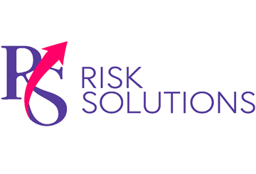Steps for Safely Maintaining Manufacturing Equipment

Provided by: **RS Risk Solutions Ltd**

Routine maintenance on plant machinery is vital to identify faults, remedy defects and ensure equipment is working as intended. Moreover, an effective maintenance programme can increase equipment reliability, which can be beneficial for optimal productivity. However, maintenance activities can also result in serious injuries or fatalities. In fact, 25%-30% of manufacturing industry fatalities are related to maintenance activities, according to HSE data, making it critical that your business carries out such activities carefully. Consider the following steps for safely maintaining equipment:

* **Plan maintenance work thoroughly.** Plan for the work before beginning maintenance activities. Specifically, conduct a risk assessment, consult any manufacturer’s maintenance instructions and implement a safe system of work. Additionally, ensure maintenance staff are provided with appropriate personal protective equipment and are fully trained.
* **Establish safe working areas**. Organise a safe place of work for maintenance workers that includes the isolation of any hazards. If you deem the work too risky, consider engaging the services of a specialist contractor. Additionally, install warning signs and barriers to protect those working nearby.
* **Isolate machinery.** Ensure moving parts have stopped before maintenance work begins. Additionally, isolate electrical and other power supplies, and allow components that operate at high temperatures to cool before handling. Furthermore,avoid work that involves entering tanks and vessels where possible.
* **Utilise downtime**. Schedule maintenance to minimise the hazards posed to both maintenance workers and other employees. Ideally, arrange routine maintenance work before opening or during shutdown periods.

Regular maintenance is essential to keep equipment, machines and the workplace safe. While maintenance activities can be dangerous, you can reduce the likelihood of accidents through sensible risk mitigation measures.

Contact us today for further information on manufacturing safety practices and risk mitigation strategies.

© 2023 Zywave, Inc. All rights reserved.