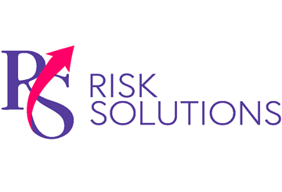
Building and Maintaining a Culture of Safety
Provided by RS Risk Solutions Ltd
May-June 2023

Workplace safety culture is centred around shared beliefs regarding injury and ill health. When such values are unclear or treated as insignificant, employee well-being may suffer. Indeed, organisational attitudes can directly affect employee actions and performance, making a well-defined and universally observed safety culture vital for operational success. In contrast, organisations with little safety guidance or lax policy enforcement could jeopardise the health of employees, risk violations and receive hefty non-compliance penalties.
To protect your employees and improve organisational success, consider the following tips for building and maintaining a culture of safety:
- Increase management commitment. Managers committed to workplace welfare set a good example to others and can help instil a concern for safety throughout the organisation. Ensure managers wear appropriate personal protective equipment, talk regularly about the importance of safety and take swift action upon seeing safety violations.

Company Fined After Worker Loses Parts of Fingers
A manufacturing company was fined after an employee lost parts of two fingers while working a night shift on 22nd April 2021. The employee noticed a problem with a machine producing face masks. Specifically, a piece of material was folding itself into the machine when it needed to be flat. Attempting to remedy the problem, the worker’s right hand got caught, severing their little finger and ring finger. An investigation by the HSE found that the company had failed to provide suitable guarding around its machinery. On 7th March 2023, the company pleaded guilty to breaching Section 2(1) of the Health and Safety at Work Act. It was fined £66,000 and ordered to pay costs of £5,440.70.
- Bolster employee inclusion. Employees actively involved in welfare enforcement may be more likely to speak up and address any unsafe activity. As such, involve workers in safety inspections and risk management practices. Additionally, provide staff with an outlet to discuss safety concerns.
- Improve communication. Safety procedures must be clearly communicated to enhance employee understanding and avoid unnecessary accidents. Moreover, make questions about health and safety a part of everyday work conversations, and always explain the purpose of any workplace protocols. Additionally, build mutual trust by listening to employee feedback.
- Implement training. Conduct regular training to improve employee understanding of risk management procedures and raise awareness of specific workplace hazards. Consider recurring training each year or multiple times a year to keep safety top of mind.
Organisational culture can take time to build, so start the process as soon as possible.
Contact us today for additional workplace safety tips.

