Summer Picnic Safety Tips
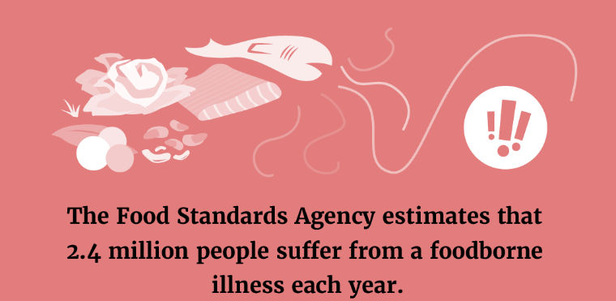
At some point throughout the summer, you may spend time outside with family and friends at a barbecue or picnic. If you aren’t careful about handling foods and beverages during these events, you could put yourself and others at risk of food-related illnesses.

Bacteria can proliferate and multiply more quickly in the summer heat, making barbecues and picnics prime breeding grounds for E. coli and salmonella. Symptoms of foodborne illnesses may include nausea, vomiting, diarrhoea and abdominal cramping.
Prevent food poisoning at picnics and barbecues with these simple tips:
- Clean. Wash cooking equipment, dishes and utensils between uses. Make sure you clean the grill’s surface after each use and wash chopping boards after preparing raw meat. Germs can survive in many places, so washing your hands and surfaces is critical.
- Separate. Use one cool box for drinks and one for food. It’s also important to separate raw foods (eg poultry, seafood and eggs) from those ready to eat. Additionally, use ice packs to keep a cool box’s temperature below 8C to prevent bacteria from growing.
- Cook. Food is safely cooked when the internal temperature gets high enough to kill germs that can make you ill. In general, cook food until it has reached a core temperature of 70C for two minutes. However, always check the advice on food packaging and follow closely any cooking instructions.
- Chill. Refrigerate food promptly since bacteria can rapidly multiply if left at room temperature. The “danger zone” for bacteria growth is 8-63C.
Remember that as summer temperatures rise, so does your risk for food-related illness. If you have a mild case, it’s important to stay hydrated. More serious food poisoning cases, which often include a fever, severe abdominal pain and dehydration symptoms, require medical attention.

Skin Cancer and You
Each year, there are approximately 16,700 new melanoma skin cancer cases, according to Cancer Research UK. However, according to the charity Melanoma Focus, 86% of skin cancer cases are preventable. Here are a few tips to protect your skin from the sun:
- Stay in the shade under an umbrella, tree or other shelter. Avoid the sun between 10am and 4pm, when the rays are the strongest.
- Wear dark-coloured clothes made of tightly woven fabrics and a hat that shields your face, neck and ears.
- Wear sunglasses to protect your eyes and the skin around them.
- Apply sunscreen all over your body and lips and reapply at least every two hours—and after swimming or sweating. Learn more about picking the right sunscreen in the infographic below.
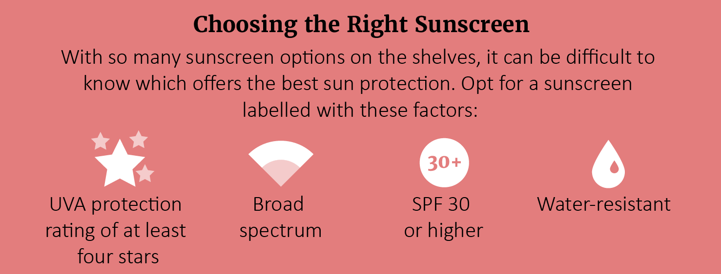
Most skin cancer cases are curable if diagnosed and treated early enough. Inspecting your skin for any spots or changes in colour or appearance is important, as new spots or changes may indicate cancer. If you have any concerns, see your doctor.

Avoiding Artificial Sweeteners for Weight Loss
The World Health Organization (WHO) released new guidance to avoid using zero-calorie non-sugar sweeteners (NSS)—such as aspartame and stevia—for weight loss. The WHO advised that artificial and natural sweeteners have not been shown to help with long-term weight loss in children or adults. In fact, their use may come with side effects, including an increased risk of cardiovascular diseases and Type 2 diabetes. The WHO’s only exception to the recommendation is for individuals with pre-existing diabetes.
This new guidance doesn’t address consumption safety; it only comments on using NSS for long-term weight loss. However, eliminating sweeteners is the healthiest option. Talk to your doctor if you have diet or disease risk questions.
Makes: 4 servings
Ingredients
2 tsp vegetable oil
6 eggs
2 tbsp milk
4 slices bread (ideally wholemeal)
2 tomatoes, chopped*
1 courgette, coarsely grated*
1 pinch ground black pepper (optional)

*Can be substituted for other vegetables

Preparations
- Turn the grill on to preheat to a medium-high temperature.
- Heat the vegetable oil in a non-stick frying pan. Add the courgette and tomatoes and cook on the hob for 3 to 4 minutes, stirring often, until soft. Spread out over the base of the frying pan.
- Beat the eggs and milk together and pour into the frying pan. Cover over a medium-low heat for 4 to 5 minutes to set the base, then transfer to the grill to set the surface—about 3 minutes. Remove from the heat and let the frittata cool for 3 to 4 minutes.
- Toast the slices of bread. Slice the frittata into wedges and serve with the toast.

Nutritional Information (per serving)
Kcal 222
Saturated fat 11g
Protein 14g
Salt 0.7g
Carbohydrate 17.5g
Dietary fibre 2.5g

Source: NHS

