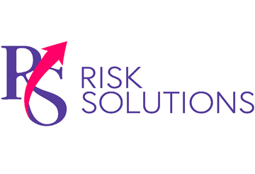
Promoting Proper Ergonomics Among Remote Workers
Provided by RS Risk Solutions Ltd
July-August 2023

Under the Health and Safety at Work Act 1974, employers must provide a safe and healthy workplace for employees, including remote workers. Although office and computer work may appear low risk, such jobs can pose significant health and safety concerns, particularly musculoskeletal disorders (MSDs).
Recent HSE data revealed that 27% of work-related ill-health concerns reported in 2021/22 were MSDs. Furthermore, neck and back pain caused by remote work may have contributed to the record number of people off sick in the UK earlier this year, according to the Office for National Statistics.
To reduce the likelihood of MSDs and other injuries, it’s critical for employers like you to promote proper ergonomics among remote workers. Consider the following tips for doing so:
- Conduct workplace ergonomics assessments. Put simply, ergonomics means fitting workspaces to users’ needs. The first step towards this is workspace assessments. Provide remote workers with an ergonomic checklist that covers all aspects of the workstation and environment. Where possible, consider guiding employees through its completion virtually.
Company Fined After Worker Fractures Arm
An engineering company has been fined after an employee was caught in a machine during a shift on 12th November 2021. While undergoing training, the employee was assisting a colleague on the company’s 60-metre lathe when the rubber material he had just applied fell from the steel mandrel. Instinctively reaching to grab the material, the worker was pulled into the machine, breaking his arm in two places. An investigation by the HSE found that the company had failed to provide suitable guarding around its machinery and had not taken sufficient measures to prevent access to dangerous parts. On 4th March 2023, the company pleaded guilty to breaching Section 2(1) of the Health and Safety at Work Act. It was fined £200,000 and ordered to pay costs of £3,653.70.
- Provide appropriate equipment. Working on the sofa or at the kitchen table could make it difficult for employees to adhere to ergonomic best practices. Make sure remote workers have a dedicated workspace and all equipment necessary to work comfortably. Ideally, invest in ergonomic office furniture for all employees, such as standing desks, chairs with lumbar support and monitor risers that help with neck alignment.
- Encourage movement breaks. Sitting for extended periods can lead to hunching or slouching, even when workers’ posture is ergonomically correct. As such, encourage workers to take regular movement breaks. Software solutions, such as apps that remind workers to take screen breaks, could be leveraged for this purpose.
- Educate employees. It isn’t enough to provide remote workers with the right equipment; they need to know how to use it. Disseminate educational guidance and resources to help remote workers implement ergonomic interventions. For instance, videos showing how best to adjust work chairs and other office equipment could be shared with staff.
Contact us today for additional workplace safety tips.

