The Link Between Health and Happiness
In the pursuit of a fulfilling life, happiness is a goal for many. However, happiness is not an isolated concept; it’s complex and connected to your overall physical and mental health. By understanding and nurturing the links between your health and happiness, you can be on your way to an enriched and balanced life.
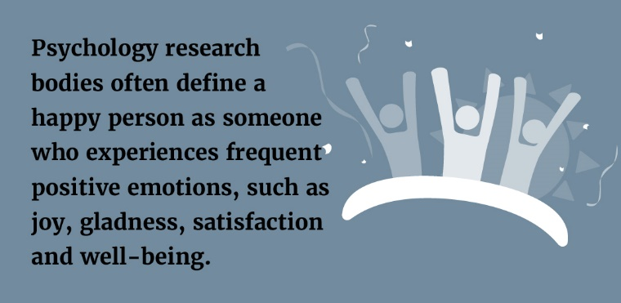

Physical Health and Happiness
Physical health forms the foundation upon which happiness thrives. When your body functions optimally, so can your overall sense of well-being. Consider the following strategies to optimise your physical health:
- Exercise regularly. Engaging in physical activity releases endorphins, the body’s natural feel-good chemicals, which elevate mood and reduce stress and anxiety. Exercise also boosts energy levels.
- Focus on nutrition. A balanced diet fuels the body and mind. Fruits, vegetables, whole grains, lean proteins and healthy fats provide nourishment to support cognitive function and emotional stability.
- Get quality sleep. Adequate and regular sleep positively influences mood, cognitive performance and emotional resilience.
Mental Health and Happiness
When you nurture your mind, happiness can flourish. Consider these tips for building your emotional resilience and a positive mindset:
- Practise self-care and stress management. It’s critical to engage in activities that bring you joy and relaxation. Mindfulness practices can also reduce anxiety and improve focus.
- Prioritise healthy relationships. Positive social interactions, supportive friendships and a sense of belonging contribute significantly to happiness.
- Seek help if needed. Mental health professionals can provide guidance, therapy and tools to help you manage and overcome life’s challenges.
The Path to Happiness
A healthy mind and body are critical components in your quest for happiness. By embracing a holistic approach to health, you can unlock the potential for a life filled with happiness, purpose and fulfilment. Contact a health care professional if you have any questions about your well-being.
Eating Healthy on a Budget
Eating healthy while on a tight budget presents challenges, especially if you have specific dietary needs. However, with proper meal planning and sensible strategies, you can still eat well without breaking the bank. Consider the following tips:
- Plan recipes. Create a weekly meal plan and consider using the same ingredients across several meals. Vary the taste of recipes with herbs and spices.
- Buy frozen or tinned. Frozen and tinned produce is cheaper than fresh and lasts longer. Opt for tinned produce in water rather than syrup, and avoid items with added salt or sugar.
- Buy store brands. Often, supermarkets’ own-brand produce is identical to their branded counterparts but presented in different packaging. Always check food labels so you can make informed purchasing choices.
- Consider discount vouchers and coupons.
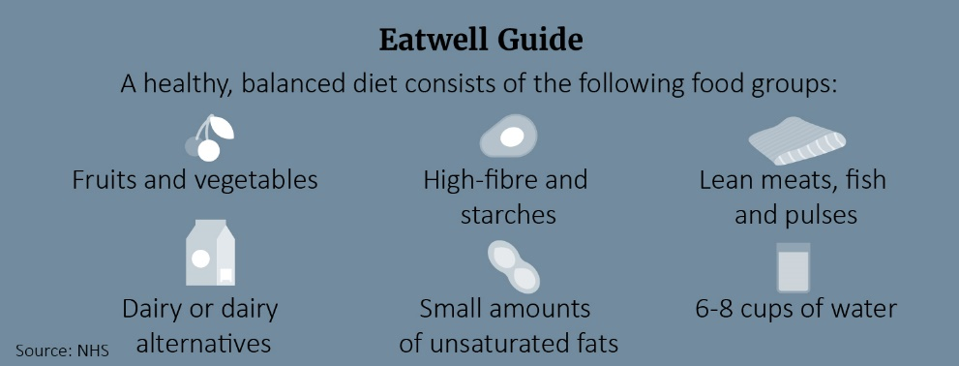
If you have additional questions about healthy eating or dietary needs, speak to your doctor.

How Often Do You Need to Exercise for Optimal Heart Health?
The NHS recommends 150 minutes or more of moderate-intensity activity or 75 minutes of vigorous activity spread evenly over the week. However, new research published in The Journal of the American Medical Association suggests that “weekend warriors” may realise the same cardiovascular health benefits as those who work out multiple times a week. A weekend warrior fits a week’s worth of exercise into a couple of days.
The research—based on data collected from 89,573 British adults—found that working out at least 150 minutes each week can help cut one’s risk of stroke, heart attack and atrial fibrillation—and those minutes can be split equally across the week or concentrated into the weekend. As long as you’re hitting 150 minutes, you can reap cardiovascular benefits. The weekend warrior schedule could be an option if you’re short on time during the week. Talk to your doctor before starting a new exercise programme.
Makes: 4 servings
Ingredients
300g easy-cook white or brown rice
4 eggs
200g skinless cod fillet, cut into chunks
120g skinless smoked haddock fillet, cut into chunks
120g skinless salmon fillet, cut into chunks
2 tsp curry powder
150g frozen peas, thawed
2 tbsp fresh parsley, chopped
1 pinch ground black pepper

Preparations
- Cook the rice in boiling water until tender. At the same time, separately hard-boil the eggs for 10 minutes.
- Place the chunks of fish into a large frying pan, then add a small splash of water. Heat and simmer for 3 to 4 minutes until the fish is opaque. Drain.
- Shell the eggs and quarter them. Drain the rice. Add the rice to the pan of fish with curry powder, peas and parsley. Heat, stirring gently, for 2 to 3 minutes.
- Serve seasonsed with black pepper and topped with eggs.
Nutritional Information (per serving)
Kcal 489
Saturated fat 2.5g
Protein 35g
Salt 0.8g
Carbohydrate 65g
Dietary fibre 3.5g

Source: NHS

