What to Know About This
Year’s Flu Season
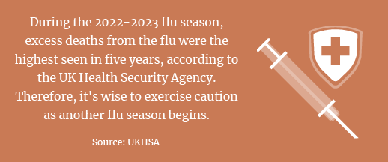
Influenza (flu) season lasts from October to May in the UK, with peak flu activity between December and March. Since the start of the COVID-19 pandemic, the timing and duration of flu activity have been unpredictable. The Southern Hemisphere also experienced an early surge of flu activity this year, which may indicate what’s to come in the UK.
Furthermore, health experts anticipate another wave of respiratory viral infections this autumn, namely from the flu, the virus that causes COVID-19, and respiratory syncytial virus. Fortunately, vaccines for all three viruses are available, depending on eligibility criteria. Vaccination has been shown to reduce hospitalisations and death and may be particularly beneficial for those with compromised health.
Tips for Staying Healthy
The flu can cause serious complications for people of any age, but children and older adults are especially vulnerable. To help keep your household healthy this flu season, consider the following suggestions:
- Avoid close contact with people who are sick, and stay away from others when you feel unwell. Because flu and COVID-19 symptoms are similar, doctors say it’s best to get tested to know what you have.
- Schedule your yearly flu vaccination to lower your risk of and severity of illness.
- Wash your hands often using soap and warm water to protect against germs. If soap and water are unavailable, use an alcohol-based hand sanitiser.
- Cover your coughs and sneezes to prevent the spread of germs.
- Sleep well, stay active and drink plenty of water to keep your immune system strong.
- Eat a nutritious diet of healthy grains, fruits, vegetables and fibre.
September and October are the best months to get vaccinated against the flu, so don’t delay getting your flu jab. Contact your doctor today to learn more about vaccines.
What Are the
Germiest Places?
Germs are a part of life—and they’re everywhere. The dry air associated with autumn and winter also makes it easier for germs to spread and linger in the air. Here are some germ hot spots:
- Home—Remote controls, kitchen counters, toilet fixtures and flush handles, sponges and toothbrush holders
- Workplace—Desktops, keyboard, mouse, chair armrests, writing tools, handles, switches and doorknobs
- School—Water fountains, doorknobs, desks and tables, shared school supplies, cafeterias and playgrounds
Hand-washing is one of the best ways to prevent the spread of germs, especially after sneezing, coughing or blowing your nose.
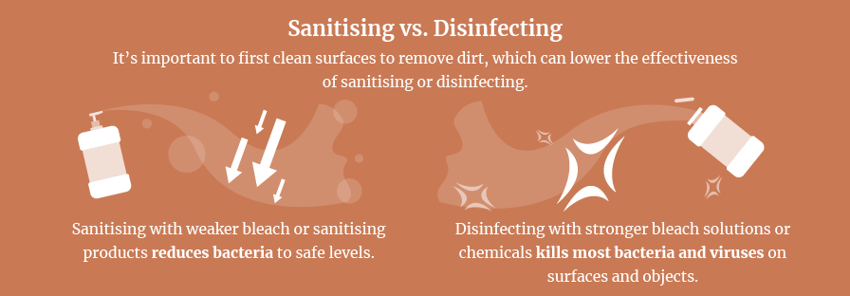
Stocking a Nutritious Kitchen
You don’t need to master the art of meal planning to eat well during the week. It can be as simple as stocking your kitchen with mealtime building blocks. Consider keeping these nutritious pantry, fridge and freezer staples on hand to make healthy eating easy:
- Tinned chickpeas can easily be added to soups or mashed with seasonings for extra protein and fibre.
- Chicken breast is a great protein to build a meal around. You could make pasta, soups, casseroles, sandwiches and more.
- Extra-firm tofu is full of plant-based protein and calcium. Its neutral flavour makes it great for stir-fries and curries.
- Quinoa or lentils are versatile options to round off meals. They are packed with fibre and protein.
- Whole-wheat spaghetti is a great last-minute meal idea. It has a sizeable dose of fibre and helps reduce cholesterol.
- Frozen spinach can easily go in egg dishes, pasta or smoothies. It is packed with four times the nutrients of fresh spinach.
With these healthy basics on hand, you can create nutritious meals that require minimal effort.

Makes: 4 servings
Ingredients
2 tsp vegetable oil
2 garlic cloves, crushed
1 red chilli, deseeded and finely chopped
300g vegetarian mince
1 tin red kidney beans in water
1 tin chopped tomatoes
200g rice
1 medium onion
1 carrot, finely chopped
2 peppers deseeded and chopped

Method
1. Heat vegetable oil in a large saucepan and add onion. Fry gently for 2 to 3 minutes.
2. Add carrot, garlic, red chilli and peppers. Fry for 2 to 3 more minutes, stirring often.
3. Add the frozen mince, beans, tomatoes, tomato puree and stock. Bring to a boil, reduce heat and simmer. Leave partially covered for 25 to 30 minutes.
4. Put rice on to cook in gently boiling water for 25 to 30 minutes.
3. Season the chilli with pepper. Serve in bowls with cooked and drained rice.

Nutritional Information
(per serving)
Kcal 400
Saturated fat 1g
Protein 21.5g
Salt 0.9g
Carbohydrate 70g
Dietary fibre 12g

Source: NHS

