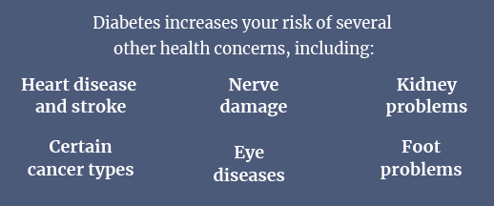
November Is Diabetes Awareness Month

According to the UK’s leading diabetes charity, Diabetes UK, more than 4.3 million Britons currently live with diabetes, and a further 850,000 could be living with the condition but are yet to be diagnosed.
Diabetes is a chronic disease that affects how your body turns food into energy. Your food is broken down into sugar (glucose) and released into your bloodstream. As your blood sugar increases, your pancreas releases insulin, allowing the blood sugar to enter your body’s cells for use as energy. A person with diabetes doesn’t make enough insulin or can’t properly use insulin. There are two main types of diabetes:
- Type 1 diabetes occurs when the pancreas doesn’t produce enough insulin. This type of diabetes is usually diagnosed in children, teens and young adults, but it can develop at any age.
- Type 2 diabetes occurs when the cells don’t respond adequately to insulin, known as insulin resistance. Of those in the UK with diabetes, about 90% of them have Type 2.
It’s also important to note that gestational diabetes can develop in pregnant women who have never had diabetes before. Gestational diabetes usually goes away after the baby is born; however, babies born to a mother with gestational diabetes could be at a higher risk for health problems.
Reducing Your Risk of Diabetes
While Type 1 diabetes can’t be prevented, you can take the following steps to reduce your risk of developing Type 2 diabetes:
- Eat a balanced diet. Consume plenty of fibre and whole grains, and understand how your foods affect your blood sugar levels. Limit your alcohol intake as well.
- Stay active. Aim for at least 30 minutes of exercise daily. Incorporate both aerobic and resistance training.
- Maintain a healthy weight. If you’re overweight, weight control can be an essential part of diabetes prevention.
Overall, half of people at risk of Type 2 diabetes can reduce the likelihood of developing the condition or delay its onset by eating healthily and maintaining a healthy weight, according to Diabetes UK. Before adopting any new diet or exercise regime, speak to your doctor.

Understanding Dietary Supplements
According to a YouGov survey, almost half (47%) of Britons take a multivitamin or dietary supplement at least once a week. Such products can be taken to supplement essential nutrients that could be missing if you lack a variety of nutritious foods in your diet. Others may be consumed to enhance athletic performance, strengthen the immune system, manage pain or improve mental health. While there’s evidence that supplements may be beneficial in some circumstances, there are also concerns, such as:
- Dietary supplements may be harmful when taken in certain combinations or with prescription drugs.
- They are often not backed by scientific research.
- High doses of vitamins (eg vitamin C) can have unwelcome side effects.
- Dietary supplements aren’t approved to treat or cure a disease.
It’s important to consult a doctor or pharmacist before taking any supplements. They can determine if supplements are right for you.
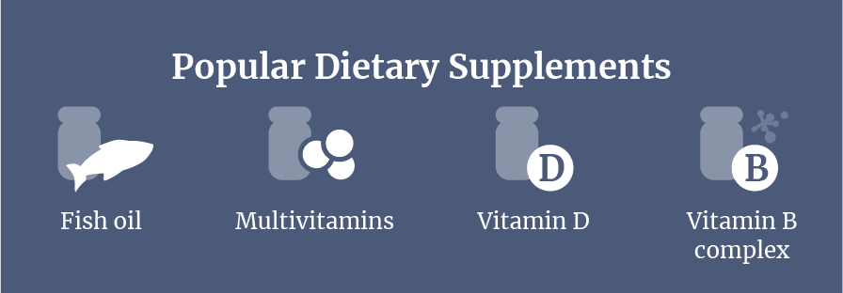
Adjusting to Daylight Saving Time
Moving the clocks forward an hour in spring and back one hour in autumn is known as daylight saving time (DST). Although DST was established to help citizens benefit from more daylight hours, it can wreak havoc on your physical and cognitive health for several days, weeks or even months afterwards.
Your internal clock regulates critical processes, including liver function and the immune system. Interruptions to the circadian rhythm, your body’s 24-hour biological cycle that regulates wake and sleep, can also impair your focus and judgment. If you’re feeling the ill-effects of DST, consider these tips for helping your body adjust to the time change:
- Exercise in the morning.
- Prioritise daylight exposure.
- Keep a regular sleep routine.
- Remove sleep disturbances.

Finally, a short nap may be beneficial if you’re still struggling with daytime sleepiness, but keep this under 30 minutes to avoid grogginess.
Makes: 4 servings
Ingredients
4 soft wholewheat flour tortillas
6 eggs
4 tbsp 1%-fat milk
2 tomatoes, finely chopped
2 spring onions, finely chopped
1 pepper, any colour, finely chopped
2tsp vegetable oil
40g reduced-fat hard cheese, grated
1 pinch ground black pepper

Method
1. Lay out the tortillas on a work surface and preheat the grill.
2. Beat the eggs and milk together in a bowl. In another bowl, mix together the tomatoes, spring onions and pepper, seasoning with black pepper.
3. Heat half a tsp of vegetable oil in a non-stick frying pan and pour in a quarter of the beaten egg mixture. Cook the hob over medium heat for a few moments to set the base.
4. Layer 1 tortilla with the cooked egg, a quarter of the tomato mixture and 10g of cheese. Grill to further set the egg and melt the cheese.
3. Roll up the tortilla and slice in half, or wrap in foil to serve later. Repeat to make the other three tortillas.

Nutritional Information
(per serving)
Kcal 229
Saturated fat 4g
Protein 15g
Salt 0.6g
Carbohydrate 17g
Dietary fibre 1.5g

Source: NHS

