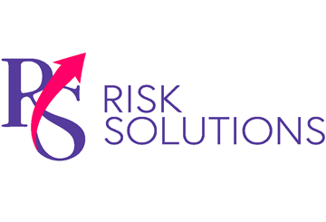
Preventing Workplace Accidents
Provided by RS Risk Solutions Ltd
Q1 2024

Recent Health and Safety Executive (HSE) data reported that 135 workers were killed in work-related accidents in 2022-23, and 561,000 were injured. Although stopping workplace accidents altogether may not be possible, employers must take reasonable steps to prevent accidents and comply with their “duty of care” under health and safety legislation. Moreover, robust accident prevention strategies are critical to any workplace risk management programme and can help employers reduce staff absences and improve workforce productivity. Consider the following accident-prevention measures:
- Employ competent staff. Complying with health and safety legislation begins with the first hire. Specifically, organisations must recruit employees with sufficient skills, knowledge and experience to conduct work duties effectively without endangering the safety of colleagues or visitors. New hires must be properly supervised until they are versed with all workplace procedures and protocols.
- Conduct risk assessments. Organisations should conduct regular risk assessments to identify physical, mental, chemical and biological risks. Next, employers must implement robust control measures to eliminate (or reduce the risk of) any
Construction Company Fined After Failing to Provide Basic Facilities
A Cheshire construction company has been fined £5,000 following a proactive HSE inspection. It is a legal requirement for organisations to provide sufficient workplace welfare facilities, including a clean supply of water so workers can wash their hands. However, a visit by the HSE found that the company had no such facilities in place. Without suitable washing facilities, staff health and well-being cannot be adequately controlled. Consequently, the company pleaded guilty to breaching Regulation 13(4)(c) of the Construction (Design and Management) Regulations 2015. It was fined £5,000 and ordered to pay costs of £1,984.
hazards identified. Employers should review risk assessments and safe working procedures regularly to continually make improvements and ensure compliance.
- Provide safe plant and equipment. Faulty tools or defective equipment can lead to accidents. Organisations must ensure that all work plant and equipment is suitable for use and maintained and inspected under the Provision and Use of Work Equipment Regulations 1998.
- Keep workspaces clean. Slips, trips and falls account for 32% of all workplace injuries, according to the HSE. Adopting strict policies around workplace cleanliness, particularly regarding clearing up spills and tidying away anything that constitutes a trip hazard, can help organisations reduce the likelihood of accidents. Additionally, employers should leverage appropriate signage (eg wet floor signs) to alert employees to hazards.
- Report accidents. All accidents and any near-misses must be reported in the company accident book. Organisations can leverage report findings to identify flaws and prevent accidents going forward.
For more workplace safety strategies, contact us today.

