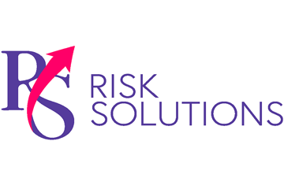
Beautifying with Care
Be safe and healthy on-site at your workplace
with these helpful tips provided by RS Risk Solutions Ltd.

Labels are Important
If you transfer a chemical substance from its manufactured packing into another container, always label the new container. This alerts others that they need to exercise caution when handling the product.

This flyer is for informational purposes only and is not intended as medical or legal advice.

© 2009-2010, 2017 Zywave, Inc. All rights reserved.

.

Tips for working with chemicals in cosmetology

Though the beauty industry is all about glamour, there are real hazards for those who choose a career in cosmetology. In fact, exposure to certain chemicals can increase the risk of serious health conditions. Potentially dangerous products include:
- Hair dyes
- Bleaches
- Permanent wave solutions
- Shampoos
- Hair styling agents
- Nail and skin care products
- Straightening products
- Brow and lash tints
- Chemical peels
- Peroxides
- Wax solvents
- Disinfectants in cleaning products
Unprotected exposure to these chemicals can cause these reactions:
Dermatitis
This general term refers to inflammation of the skin; however, it can signify either an irritant reaction to chemicals or a more serious allergic reaction.
Asthma
Chemicals common in hairdressing and nail services may aggravate pre-existing asthmatic conditions or even cause occupational asthma.
Cancer
Though there is limited data to support this claim, some products used in the cosmetology industry are suspected to cause cancer.
Hazardous chemicals can enter the body through the skin, through inhalation or by swallowing. Generally, eye and throat irritation will begin immediately upon exposure, followed by other potentially dangerous reactions. Not everyone will develop a negative reaction to these products. These factors affect how you will react:
- Toxicity of the substance
- Amount of the substance
- Length of exposure
- Frequency of exposure
- Route of entry into the body
Assess Your Risks
Read the Safety Data Sheets (SDS) for all chemicals that you work with on the job. These sheets provide information on how to properly handle, store and discard potentially hazardous chemicals.
The SDS also provides information on what to do if you or a co-worker is exposed to the chemical and has a bad reaction. Do not take any chances on your health. Read and understand SDS, and ask your supervisor for clarification if you do not understand the directions.
Also, always wear protective clothing, such as gloves and aprons, and wash your hands thoroughly before eating, drinking or smoking after handling hazardous chemicals.

