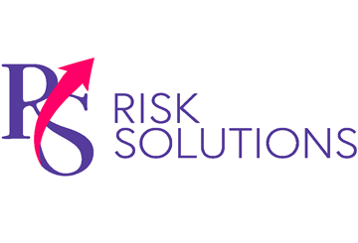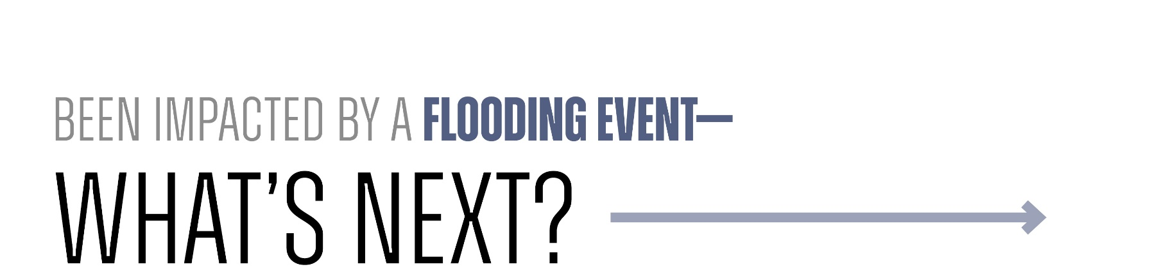

The immediate aftermath of a flooding event can be overwhelming and knowing where to turn is difficult. **RS Risk Solutions Ltd is here to help.** The following guidance outlines some need-to-know information to help you navigate recovery.

# Insurance Tips

* Contact your insurance provider immediately to begin the claims process. Ask what to expect and note any filing deadlines or required documentation.
* Itemise damaged possessions and take photos. Afterwards, discard perishable foods and items that pose a health hazard (eg soft furnishings that may harbour mould.)
* Consult your insurance provider before signing contracts with cleaning, remediation or maintenance contractors. Always check that contractors are licensed and insured.
* Meet with your loss adjuster to discuss the next steps.

# Personal Safety Guidance

* If you evacuated, don’t return home until authorities say it’s safe to do so.
* Flooding may contaminate drinking water. If you notice a change in your tap water’s colour, taste or smell, contact your water company immediately and drink bottled water in the meantime.
* Never touch electrical equipment if it’s wet or you’re standing in water.
* Flood water can contain sewerage, spilled chemicals and hidden debris; wear protective clothing, gloves and a respirator to prevent injuries and illnesses.
* Take steps to dry out your home to prevent mould.

# Weather Alerts

* GOV.UK Flood Warnings:   
  <https://check-for-flooding.service.gov.uk/>
* Met Office Weather Warnings: <https://weather.metoffice.gov.uk/warnings-and-advice/accessible-uk-warnings>

# Disaster Assistance Recovery Resources

* Floodline: 0345 988 1188
* Your local council:   
  <https://www.gov.uk/find-local-council>
* National Flood Forum: 01299 403 055 or <https://nationalfloodforum.org.uk/>
* The Samaritans (mental health support): 116 123 or <https://www.samaritans.org/how-we-can-help/contact-samaritan/>

Knowing where to go for help and what to tackle first can be challenging in the aftermath of a flooding event. RS Risk Solutions Ltd can guide you through recovery actions, streamline the insurance process, and help you and your family regain some normality. Contact us today to find out more.